ECE/COE 1896

Senior Design

Final Report

Team #8

Prepared By: Lauren Gilfillan

Chad Collina

Jonah Belback

Justin Lipner

# Table of Contents

Table of Contents i

Table of Figures iii

1. Introduction 1

2. Background 1

3. System Requirements 3

3.1.1 General 3

3.1.2 Physical 3

3.1.3 Electrical 4

3.1.4 Software 4

4. Design Constraints: Standards and Impacts 5

4.1 Design Constraints 5

4.1.1 Time 5

4.1.2 Manpower 6

4.1.3 Budget 6

4.1.4 Physical Space 6

4.1.5 Testing Environment 6

4.2 Impacts in Non-Technical Contexts 6

4.2.1 Environmental 6

4.2.2 Public Health 6

4.2.3 Global, Cultural, and Societal 6

4.2.4 Diversity, Equity, and Inclusion 6

4.2.5 Welfare and Safety 7

4.2.6 Economic 7

5. Conceptual Design 7

5.1 Summary 8

5.2 Electrical 8

5.2.1 PCB 8

5.3 Software 11

5.3.1 Architecture 12

5.3.2 Architecture’s Robustness with Fake versions 13

5.3.3 Stereo Depth Perception 14

5.3.4 Depth 14

5.3.5 Stereo Correction 14

5.3.6 Size 20

5.3.7 Dataset Collection 22

5.3.8 YOLOv8 23

5.3.9 ONNX models 24

5.3.10 Finite State Machine 25

5.3.11 User Interface 25

5.3.12 Path Planning 26

Hardware and Peripherals 26

5.3.13 Arduino Mega 26

5.3.14 Bluetooth Module 26

5.3.15 Jetson Orin 26

5.3.16 Cameras 26

5.4 Motor Control 28

5.4.1 Commanding the ESC 28

5.4.2 Drive control 28

5.5 Chassis 30

5.5.1 Production and Fabrication 30

6. Team and Timeline 32

6.1 Team 32

6.1.1 Lauren Gilfillan 32

6.1.2 Jonah Belback 33

6.1.3 Chad Collina 33

6.1.4 Justin Lipner 34

6.2 Timeline 34

7. Testing Procedures 37

7.1 Hardware Systems 37

7.1.1 Buck Regulator 37

7.1.2 Reverse Current Protection 37

7.1.3 PCB Stress Test 37

7.1.4 Battery Life 37

7.2 Software Systems 37

7.2.1 Computer Vision 37

7.2.2 Motor Controls 39

7.2.3 FSM 40

7.2.4 Bluetooth + Arduino Communication Latency 41

7.2.5 Path Planning Generation 41

7.2.6 UI – Usability 41

7.3 Testing Results 42

7.3.1 Hardware Systems 42

7.3.2 Software Systems 46

8. New Skills Acquired and Learning Strategies 67

8.1 Lauren Gilfillan 67

8.1.1 Python UI Generation 67

8.1.2 Bluetooth Communication Protocol on a laptop 67

8.1.3 Patience 67

8.2 Chad Collina 68

8.2.1 Interfacing with an ESC 68

8.3 Jonah Belback 68

8.3.1 System Engineering and Architecture 68

8.3.2 ROS 68

8.3.3 CNN Model 68

8.3.4 Stereo Vision 69

8.4 Justin Lipner 69

8.4.1 Soldering 69

8.4.2 Electronics 69

9. Conclusions and Future Work 69

9.1 Limitations 69

9.2 What We’d Do Differently 70

9.2.1 Chassis 70

9.2.2 Microcontrollers 70

9.2.3 Electrical 71

10. References 71

10.1 General 71

10.2 Electrical 72

10.3 Software 72

# Introduction

Debris is a serious hazard for any airline company because of the impacts it can have on planes during take-off (see <https://en.wikipedia.org/wiki/Air_France_Flight_4590>). Many airline companies use humans to check for debris at set intervals after some type of large sweeper vehicle has made a pass down the runway. Even airmen and sailors in the military are required to make these checks on aircraft carrier runways. As you can imagine, this process is time-consuming and prone to human error. Our solution is to automate this task using a robot.

Using a machine learning model on a Telescopic Camera’s camera feed, it will find objects from a very far distance during a search pattern, the robot will then start approaching the object by keeping it in frame. Once the robot is close enough that it can pick it up on a separate machine learning model on a Stereo Camera provided to us by Carnegie Robotics, it will use the Depth Map provided by the camera to do percision navigation to the debris and collect it.

We borrowed a Jetson Orin Nano from Carnegie Robotics which we’ll use to do all computer vision-related tasks. Since this is expected to be a computationally demanding and relatively slow task, we want the Jetson to focus exclusively on image processing. An Arduino Mega was used for the motor controls and to meet any other software requirements. The Jetson reads the stereo camera input, identifies if a debris item is present, then the FSM decides what needs to be done next.

Finally, we’re going to have a Bluetooth communication system on the robot. We want to simulate how it would operate in a real airport environment by sending and receiving messages to the control tower. For our use case, the user will serve the role of “air control” and use a smartphone to send/receive messages to/from the robot via any standard Bluetooth communication app.

# Background

The Concorde was a supersonic airliner capable of flying 100 people from New York to London in two hours with the total program cost estimated at £70 million ($2.24 billion today). On July 25th, 2000, a part of the Air France Flight 4590, crashed shortly after take-off with all 109 of its occupants and 4 additional people on the ground killed due to a piece of debris that had fallen from a DC-10 from the previous take-off which destroyed the Concorde’s left side tires who’s own debris had generated enough high-pressure to destroy 3 different areas of the fuel tank and cause a massive leak [I1].

It is now mandatory to clean large runways several times a day with a large sweeper operated by four people followed by two separate vehicles driving along both sides of the runway. This process takes two hours and is done daily when required by unusual conditions such as construction activities or meteorological conditions, and immediately after an accident or incident per FAA Regulations.

The 300 largest airports service a little less than 55 million movements per year with over 60,000 Foreign Object Accidents accompanying them costing the aviation industry $13 Billion USD every year in March 2008, rising to $22.7 Billion USD as of May 2023. In 2010 the FOD (Foreign Object Damage) strike rate was calculated at 4.0 events per 10K operations, runway FOD strike rates at 2.1 per 10K operations, and damaging runway incidents at 1.6 per 10K operations [I2]. In 2008 it was estimated that FOD incidents caused an entire engine replacement at an average of once per every 340,000 operations, a Tire replacement every 1887 movements, and noticeable Body damage every 3846 operations [I3].

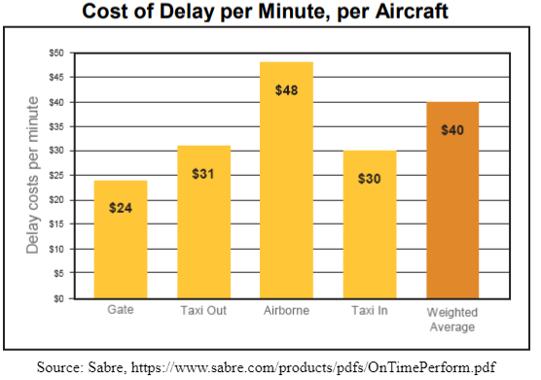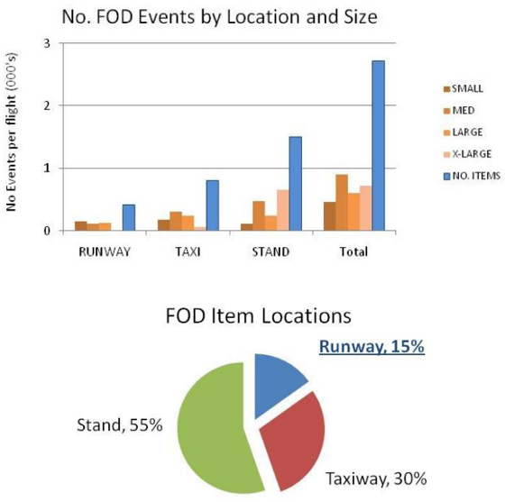

Figure 1: Cost Delay per Minute, per Aircraft Figure 2: FOD Location

It is estimated that 502 million pieces of litter are in the state of Pennsylvania alone or an average of 1,030 pieces per mile. This litter damages tourism, and business, with tax costs up to 68 million dollars. Some debris even finds its way into our waterways [I4], which releases tons of microplastics; Plastic particles 1 micrometer to 5 millimeters in diameter, which can cause cardiovascular disease, respiratory disorders, cancers, reproductive-system disorders, inflammation, and brain damage[I5]. A recent study found that the amount of nanoplastics, less than a micrometer in diameter, in bottled water was 110,000 to 400,000 particles per liter [I6]. Micro and nanoplastics are so prevalent in the human world that Impact studies are hindered by a lack of a Control Group [I7].

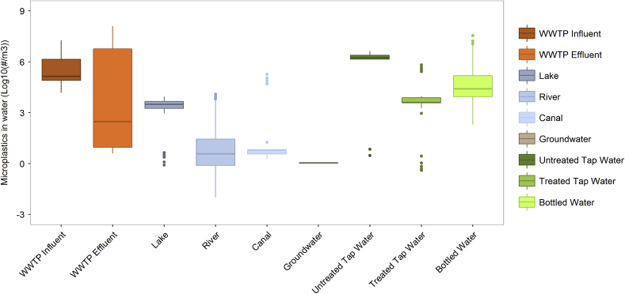

Figure 3: Microplastics in Water Sources [18]

Even besides these side effects of microplastics making their way into our drinking water, is what litter does to our environment. When litter finds itself in our lakes and rivers: plastic becomes choking hazards or creates blocks in their digestive systems when swallowed by wildlife and poisons them with the same effects as microplastics on humans, organics decrease oxygen levels in the water suffocating the ecosystem and produce an overabundance of algae, and flammable materials become fire hazards leading to wildfire. It's estimated that at least 100,00 marine animals die from plastic pollution every year [I9]. And that over 700 species are at risk of extinction [I10].

Our Solution is to automate the process of collecting either litter or debris with an autonomous robot designed to travel down a road in set areas, or on a runway in packs, on a predetermined set path where it identifies debris and litter using object detection Machine Learning, calculate its location using a depth map from a stereo camera, then pick up said debris before reporting its location of classification of debris for statistical analysis to its reported station. The example we will present at the Expo will be one that specifically collects debris on runways, but the modules are identical in function.

# System Requirements

### General

* Carnegie Robotics is the sponsor of our project and as a result, the robot needs to utilize a KS21i Stereo Camera provided by them.

### Physical

* The robot should be able to accurately reach a destination within a 3% margin of error.
* The robot needs to utilize a KS21i Stereo Camera provided by Carnegie Robotics.
* All components must be securely mounted on the chassis, only exception being the which is the user's controller.

### Electrical

* There should be enough power to reliably supply all necessary peripherals.
* There needs to be a working PCB that integrates the stereo camera, Jetson, and Arduino.
* Reverse current protections in case the battery is accidentally connected backwards.
* Battery should last at least 1 hour during operation.

### Software

#### Path Planning

* The software shall be able generate a quadrilateral shaped path based off of 4 provided GPS points
* The software shall generate the path in terms of localized {x,y} (in meters) coordinates
* The software shall create a path in which the bot does not deviate onto the runway, unless directed to do so
* The software shall handle edge cases such as...
  + It is given 4 of the same GPS points
  + It is given GPS points that generate a polygon of zero area
  + The GPS points given generate a path that is unreasonably large for the bot to search over

#### User Notification and Interface

* The user interface shall be accessible via a Mac or Windows OS laptop
* The user interface shall communicate via Bluetooth.
* The robot shall be able to notify the user when a detected piece of trash is detected and its relative position in {x, y} coordinates
* The user shall be able to upload the starting point of the robot as a GPS coordinate.
* The software shall be able to generate a comprehensive path that does a reasonable job of covering the entire inputted region.
* The user shall be able to stop the robot on command.
* The user shall be able to pause the robot on command.
* The user shall have an additional ‘Emergency’ Stop
* The user shall regularly be updated on the status of the connection to the bot
* The user interface shall inform the user if they enter GPS points that cannot generate a valid search area
* The user interface shall inform the user if they try to send a message when Bluetooth is not connected
* The user interface shall inform the user if they try to start the bot without setting a path

#### Finite State Machine

* The bot shall run a several state FSM on the Jetson Orion
* The FSM shall take in inputs from the Motor Driver, the Object Detection Algorithm, and the User Interface
* The FSM shall be able to return to an emergency stop state at any point in the program within 10 ms
* The FSM shall take no longer the 50 ms to transition between states
* The FSM shall include 8 States
  + 0 – Emergency Stop State
  + 1 – Stopped State
  + 2 – Pause
  + 3 – Start / Generate Path
  + 4 – Initiate Detections with Telescopic Camera
  + 5 – Object Detected / Seek Approval for UI to Retrieve
  + 6 – Initiate Detections with Stereo Camera
  + 7 – Picking Up Trash
  + 8 – Return to Last Path Coordinate
* The FSM shall be robust enough that it can always complete a circular path and is never ‘stuck’ in one state and can handle edge cases from inputs

# Design Constraints: Standards and Impacts

## Design Constraints

### Time

We have time constraints from multiple sources such as other classes, work responsibilities, commuting, and life in general. Each team member operates on a different schedule which further narrows the time frame we have available to work together on an aspect of this project. There’s never enough time to do something because ideally, one would have infinite time. It’s our responsibility to make this prototype work regardless.

### Manpower

The systems we want to implement are complex and need to work together. The more people we have the easier it would be to make sure these systems are all working properly. Since we only have a team of four people, we’ll need to focus on the most important design requirements while scaling back when needed.

### Budget

Robotics as a hobby is quite expensive and industry-level robotics even more so. With a budget of only $200, we had to get creative with how we’re going to implement the features our robot requires.

### Physical Space

We have a limited amount of physical space for mounting required items on the RC car. As a result, we have to carefully consider how we’re going to meet our physical design requirements.

### Testing Environment

Ideally, this robot would be tested on an airline runway. This would allow us to gain feedback on how the robot operates in its expected environment. This is important because the machine learning model that detects objects has to be trained on images that simulate the surface at an airline runway as close as possible. Impacts in Non-Technical Contexts

## Impacts in Non-Technical Contexts

### Environmental

Since our solution aims to assist with the prevention of airplane crashes due to FOD, this directly has an impact on saving resources (planes). Additionally, preventing plane crashes helps avoid pollution to the environment.

### Public Health

Because this product is working on reducing accidents with airplane take-offs, we are reducing the risk of civilian death and thus improving public health in terms of airplane-related deaths.

### Global, Cultural, and Societal

Public fear of airplanes is relatively widespread. By creating a product that increases the safety of airplanes during takeoff (the most dangerous time in which an airplane operates), we are helping reduce social fear of airplanes and making them more accessible.

### Diversity, Equity, and Inclusion

This project has no direct effect on diversity, equity, and inclusion.

### Welfare and Safety

The buck regulator can supply up to 6 amps of current so the wires routing power should be at least 14 gauge to supply this amount of current safely. The PCB traces should also be at least 60 mils in width while on a 2-oz copper board to avoid any trace destruction from the supplied current.

### Economic

This product has an economic impact because it helps prevent catastrophic accidents that cost airports lots of money and reduces the labor needed to manually check for debris.

# Conceptual Design

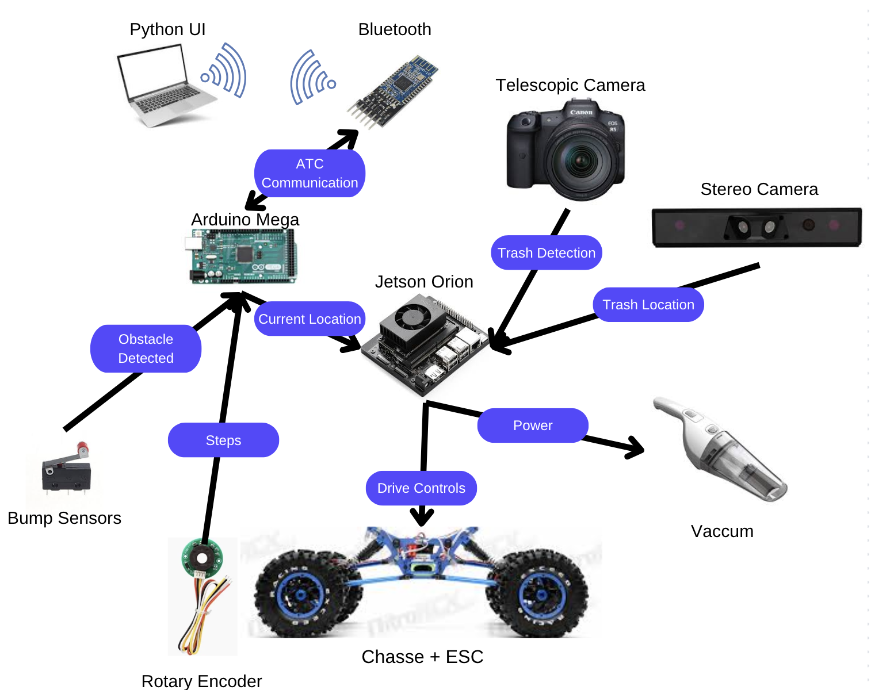

Figure 4: Conceptual Diagram

Prior to starting the development of our runway sweeping robot we discussed multiple ways on how we would implement our various subsystems. We decided that the RC car would remain on its own battery and circuit, while our computing systems would be on their own battery with a different power distribution circuit. This was to simplify our design since the RC car had already been working as a standalone device.

We had intended on using a timing table for keeping track of distance but after testing we did not have the accuracy we required. This meant that a new method of keeping track of distance was needed and decided to implement KY40 encoders instead.

Initially we had also intended on using an ESP32 with Bluetooth built in, however the microcontroller was creating more issues than it was solving so we decided to move to a more familiar but less capable platform instead. An Arduino Mega 2560 Rev3 became our designated motor controller, and we used an external Bluetooth instead.

We originally planned on using a Jetson Nano with a 32gb SD card given to us by Dr. Dickerson however there was some issues with its firmware that lead to any flashed image to be corrupted, so we switched to a Jetson Orion Nano and had no issues flashing to it with a 256gb SD card personally provided to accommodate its large image file.

[Video of a live demonstration](https://drive.google.com/file/d/1vJ1UxzDBIDoiHNBPUd-n8gUcGKPPp_dw/view)

## Summary

This robotic system is designed to autonomously detect and remove debris from airport runways to prevent potential hazards that could lead to costly accidents or damage to aircraft during takeoff. The robot operates by navigating a predefined path using derived from GPS points selected on the UI and detects debris through both a stereo and telescopic camera combined with a custom trained YOLOv8 model for object detection. Once debris is identified, the system calculates its position and navigates to the object. The robot is built on an RC car chassis with all the components securely mounted using 3D printed and laser cut brackets. Power is supplied through a dual-battery system, with a LiPo battery powering the RC car and the peripherals are powered by an 18V, 6 Ah, NiMH battery.

To handle computational tasks, the robot uses a Jetson Orion Nano for machine learning and image processing, while an Arduino microcontroller manages motor control and communication. The two modules are connected via a serial interface to ensure efficient task coordination. The robot communicates with the user via a Bluetooth-enabled python program, allowing the user to start or stop the robot, upload GPS coordinates, and receive updates on detected debris and system status.

The robot's finite state machine (FSM) governs its behavior, transitioning between path-following, debris collection, and obstacle avoidance states. The robot also avoids obstacles utilizing bump sensors.

This system addresses key design challenges, including the computational demands of machine learning, limited power budget, and constrained hardware resources. The modular design allows for scalability and adaptation to other debris-collection applications, while the proof-of-concept functionality ensures that the system meets the core requirements for runway debris management.

## Electrical

### PCB

The PCB was created to supply power to the Stereo Camera, Nvidia Jetson, and Arduino using an 18V battery. The Texas Instruments TSP54550 was chosen because of its output voltage range which aligns with the requirements for the Jetson and Arduino. This IC also can output up to 6 amps of current which is more than enough for the Jetson and Stereo Camera combined. 14-gauge wires were soldered to the PCB and crimped with 14-gauge connectors. We connect these cables to the battery to power the PCB. Finally, the PCB has an onboard LED at the output to indicate visually that power is correctly being distributed.

An N-MOSFET (Q2) that is designed for high power applications was chosen to serve as the switching MOSFET. Special attention was given to choosing a MOSFET with a low $R_{DSON}$ value to ensure as minimal heat dissipation as possible. It should also be noted that the switching frequency of the MOSFET was chosen to be 500 kHz, half of its maximum value. Our domain expert, Mathew, told us about problems he had with switching MOSFETs frying themselves during operation in the past. We started with 500 kHz as a baseline which ended up causing no problems while the PCB was in use.

A P-MOSFET (Q1) was chosen to prevent reverse currents from destroying components on the PCB in the event the battery is connected backwards. Again, a low $R_{DSON}$ was chosen to make the MOSFET as efficient as possible.

The final design of the PCB is shown in the figure below, which was heavily influenced by the TPS54550 datasheet’s recommendations. All resistor and capacitor values were chosen based on the datasheet.

[Video of it being tested on the max possible load with all models firing at once, all cameras getting live feed, and possible all calculations being done.](https://drive.google.com/file/d/1cr5nuXcWtFEgZJ8FRmwLba97_p56_mae/view?usp=sharing)

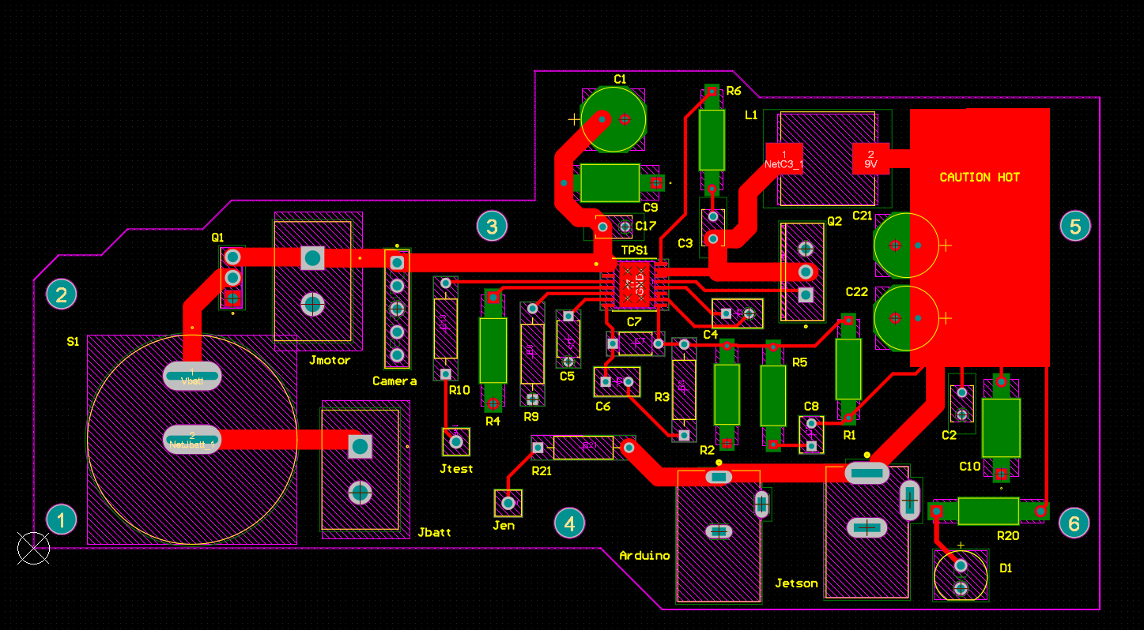

Figure 5: PCB Design

The Stereo Camera can take input voltages varying from 9V-36V. 18V was chosen as the highest practical voltage (anything higher would require massive and expensive batteries). The Stereo Camera operates at 12 watts max. Assuming it will indeed consume this much power and is fed an input voltage of 18V, the expected current draw is 12W/18V=0.667A. We’re not using all features of the camera, so the camera wasn’t consuming 12W of power, but the PCB was designed as if it were just to be safe.

According to the PSpice Simulation, there were inrush currents at the input and output up to 8A. The soft starter feature on the TPS54550 was used to help limit these currents, so the trace widths of the PCB were designed for currents slightly less than the inrush value. Using the Saturn PCB Toolkit, a trace width of 85 mils was chosen for the high-current power lines. This would allow a current of 7.55 A to safely through the traces continuously on a 2 oz copper board with 1 oz plating thickness.

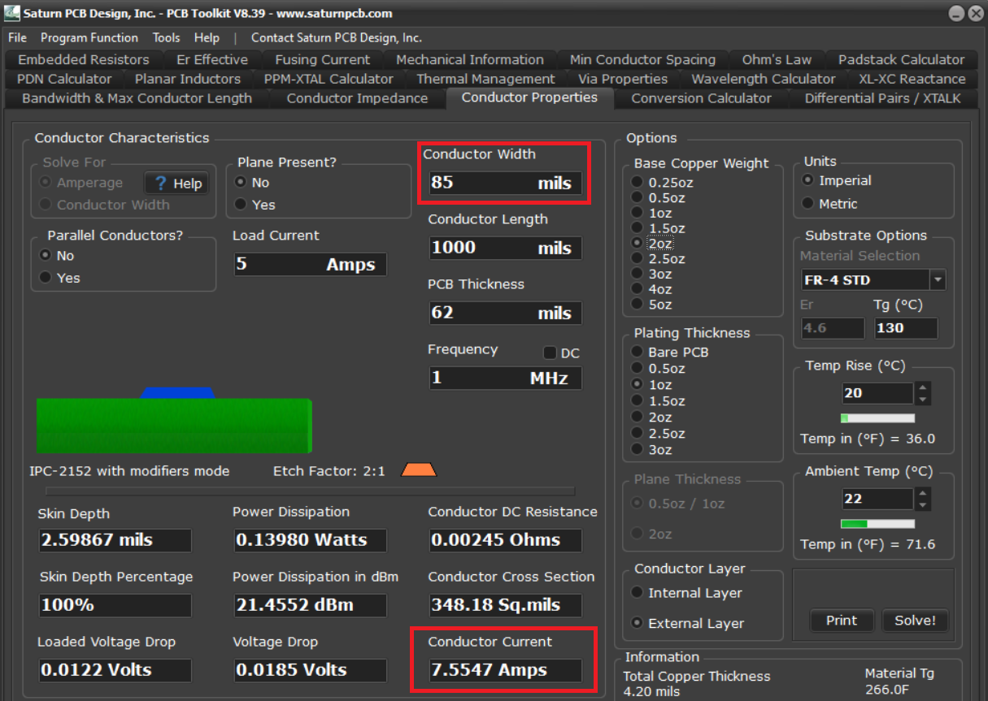

Figure 6: Trace Width

Additionally, the PCB was designed with 4 layers to best conform to the datasheet’s recommendations (inner ground planes). Two power jacks designed to withstand the max current through the Arduino and Jetson were chosen to power each one respectively. Finally, there is an extra power header called ‘Jmotor’ that was added as a future proofing feature for an external motor.

## Software

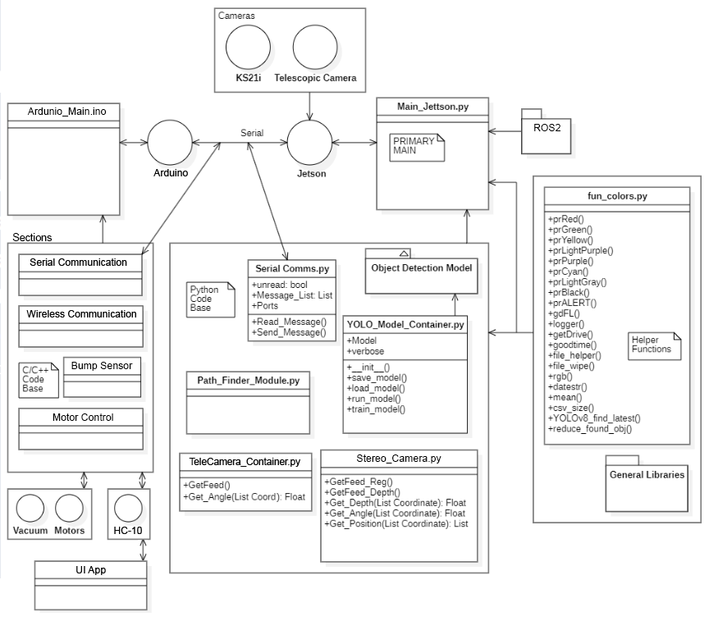

Figure 7: Software Architecture Diagram

### Architecture

There was a big focus on having a lot of printouts for all the functionality and start-up of the different modules to allow for as much comprehension of the system as possible. One of the ways to achieve this was to use color as much as possible to differentiate different types of messages and sections of the console.

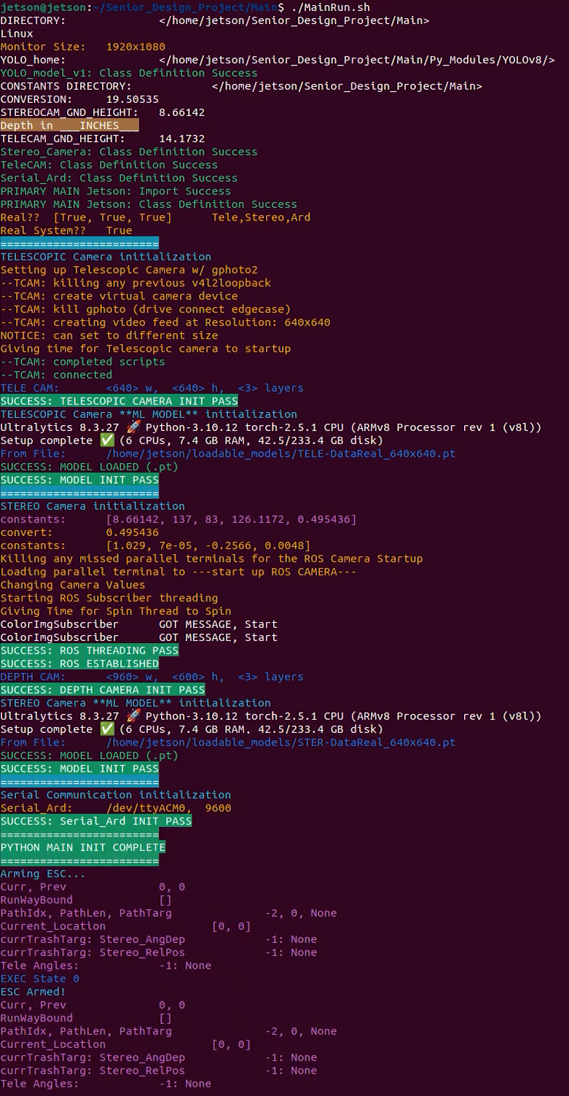

Figure 8: Main on Linux Console

The was also a large amount of raising errors to catch the system in scenarios that would make it unreliable or raise further errors. Giving these raises easy to understand descriptions and navigating dependent libraries to find these was another focus.

One example is when the ROS2 subscriber nodes for the stereo camera don’t update their local variables from a new posting by the publisher within 5 seconds, it raises an error since the feed being given to the system is no longer accurate and is unreliable.

Another is understanding gPhoto, a Linux library used to make a DSLR camera a webcam, for our telescopic camera and catching when there may have been an error with sub-processed console commands during the Telescopic Camera’s initialization and raising an error to signify the module didn’t initialize correctly.

### Architecture’s Robustness with Fake versions

One addition to the architecture was that when a module in MAIN runs into an error during its class’s initialization either from not being plugged in or separate issue with startup, rather than crash with the caught error immediately it will prompt in console whether the user wants to switch to a “fake” alternative. If declined, the caught error is raised and the program crashes out.

If accepted however, an alternate version of the module is used for the system. In some cases this is a separate class, like with the fake ‘Arduino’ module in charge of communication with the Arduino will instead ask for a prompted string to use in place of a real received message when the class is pinged give any store messages in cache.

For Telescopic and Stereo there is not a separate class but instead during the FSM the user is prompted when the camera is made to run a detection if it should have a detection. If so, it gives the FSM a predetermined detection. If not, it proceeds without a detection like normal. The initialization for a ML Model is skipped if the dependent camera fails.

There is also additional functionality such as when the Stereo camera is operational but the telescopic isn’t and is running “fake” where the user can switch the Telescopic’s Feed and Model to be the Stereo’s. There is also the option during the FSM to force a message to the Arduino between the FSM’s functionalities. For consideration of all possible edge cases of “fake” module’s behavior through the entire system, there are 18 different alterations.

The purpose of this architecture was to maximize the ability for testing and to continue operation when a certain module wasn’t necessary to the given experimentation.

Some other places of this purpose is the multitude of testing scripts to work on different parts of the system including Dataset collection, the Weight-approach in bounding-box correction discussed later, performance of the models and the usage of the detections, and general view of the different feed of the model with the Telescopic Camera’s feed, Stereo Camera’s Auxiliary feed, and the depth map normalized and colored NULL areas. Many of these functionalities are a part of the same testing script where the user is prompted for what modules they want to utilize and depart from initializing unwanteds to reduce startup time.

### Stereo Depth Perception

When deciding the depth of an object, we take the bounding-box containing the object and calculate the 95th percentile value of the depth map. This ensures the value returned is balanced to ignore some of the included background depth values and track the objects nearest point on its surface from the camera. It also works against having null values within the box which would previously give issue with taking the depth at the center of the box.

Another approach we considered but didn't try due to time constraints would be to weight all the values within the box to its distance from the box's center point, take a 95th percentile, then reconvert to a balanced depth.

After depth of the object is calculated we calculate its horizontal angle from the camera by scaling its bounding-box’s center coordinate on the x-axis, its distance from the center of the camera, and the HFOV value. Positive angles are to the right of the camera, and negative angles are to the left. With the depth and the angle, it's then handed over to the FSM as a detection to hand off to the motor controls to capture the object.

### Depth

After configuration of the Stereo Camera to give the best depth map possible, there are inaccuracies within the provided depth map. So, the map used is from the provided disparity map and converted to depth with the camera’s configuration matrix. From there it is adjusted to real units from a scaled value with a linear relationship found in Testing.

### Stereo Correction

When using a detection on the Auxiliary Camera and using that bounding-box on the Depth map in the perspective of the Left Mono-Chromatic Camera, the pixel coordinate conversion isn't exact due to the cameras being separate from each other whether or not the dimensions of images coming from them are the same or their FOV is similar. This is the same process and problem that Stereo Imaging utilizes in the first place.

With large images that take up a lot of either image, this isn't a big enough problem to worry about. The bounding-box being shifted off of the object would at most miss 20% of the object with a difference of 50 pixels or so. However, with small objects, where the width of the bounding-box is 50 pixels or less, you miss the entire object or enough of it where the depth measurement you derive is inaccurate, unreliable, and generally unusable.

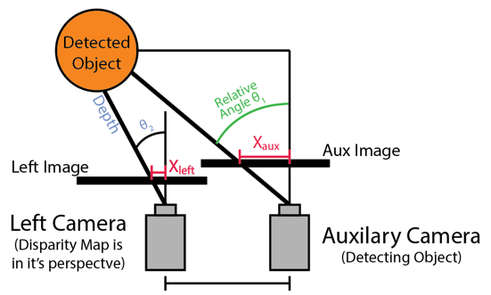

Figure 9: Diagram of the problem

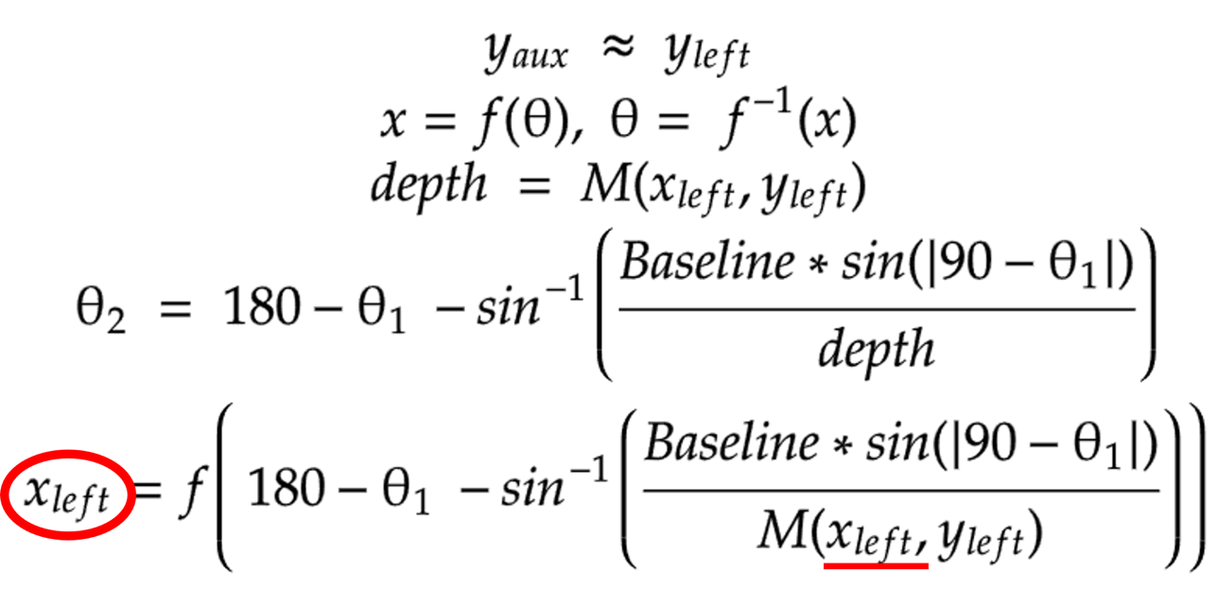

Figure 10: Problem demonstrated mathematically

The biggest problem with this is that the conversion from the utilizes the depth of the object. But we start at the Auxiliary Camera when the object is detected on it, so you need the depth to do the conversion, but you can’t obtain the depth unless you convert it.

The first attempt was to approach the conversion with weights attached to the horizontal position of the detection and the width of the bounding-box in four different cases, but this didn't consider the depth enough to be useful.

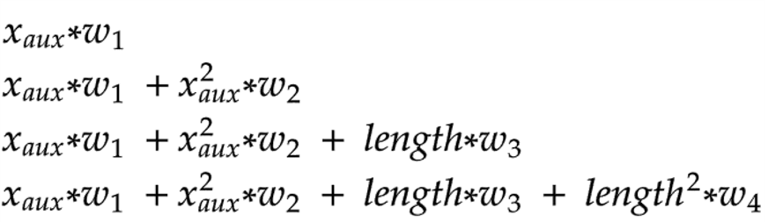

Figure 11: Weight equations cases

The second attempt was to utilize something called an ‘Epipolar Line’ calculated from the configuration matrix on both cameras to derive a line on both images where the perspectives are the same. However, in our case where the cameras identical vertically but shifted in position horizontally, this line straight across the x-axis and useless. Further use of the line would’ve been to calculate the conversation reversely with the depth on each point on the line and using a minimum error, but in our case there's no way of calculating such error.

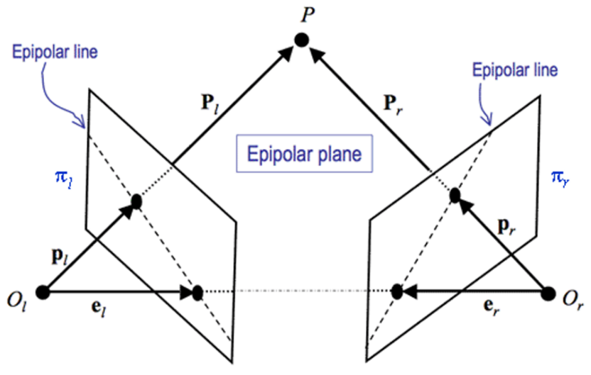

Figure 12: Epipolar Line diagram

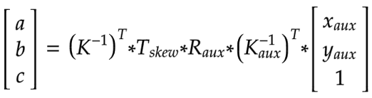

Figure 13: Epipolar Line calculation

The third attempt was to use a sliding window on an area from the bounding-box placed on the depth map formally without any considerations, with expansions to the left and right equally from some scaler. Windows with a significant number of null values would be removed, such limit being taken from the windows within the area or a set value of 85% if less than such. Individual windows within the area would weigh themselves with their contained depths, weigh the windows center from the center of the scanned area, and give that windows level of success as a conversion. The 95th percentile of successful window would then be selected and used as the converted bounding-box from the Auxiliary Camera to the Depth Map.

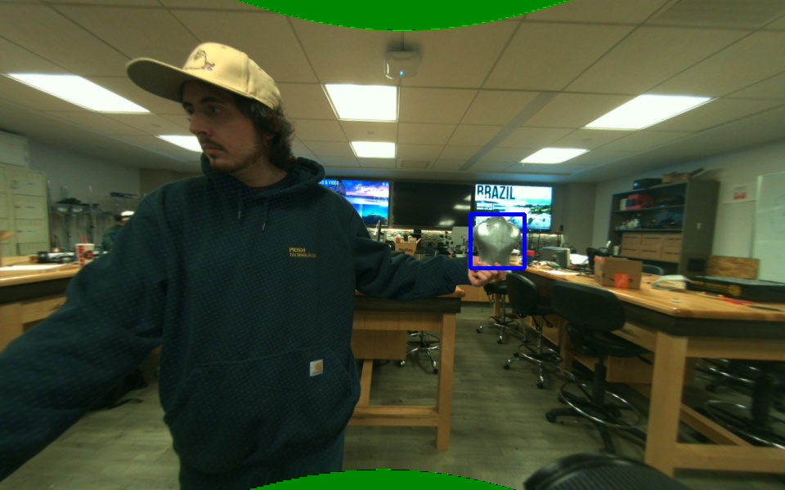

Figure 14: Full image of the detection on the Auxiliary Camera

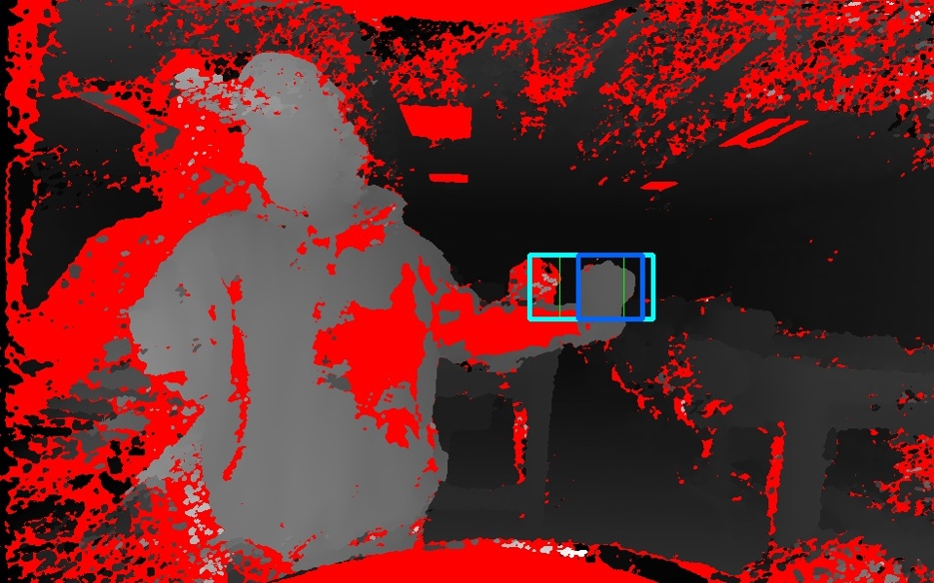

Figure 15: Full image of the effects of the Scaling Window

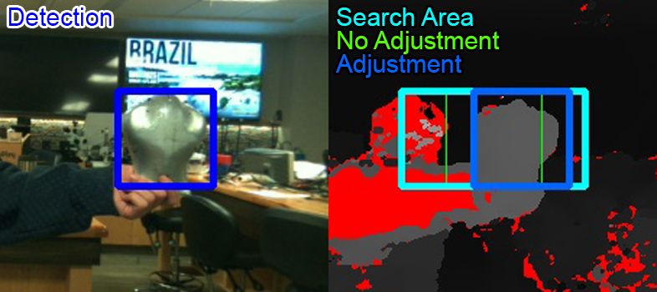

Figure 16: Cropped and labeled areas of importance

In these figures above, you can see how when the detected object is a small part of the image: the immediate conversion, the green box on the depth map, it misses most of the image. However, when the sliding window is in effect, the bounding-box is corrected to include more of the object.

Here the box starts at the very start of the object on the left side while the initial detection has some room on either side of the actual object. The conversion isn’t perfect; however, it does include the entirety of the object so whatever background depth values are left in the image would be the same amount as a perfect conversion, same as the amount of depth values of the object. So, for what we care about, this would be considered perfect enough.

This method of conversion was a major roadblock in the development of this project with a lot of challenges specific to itself. A significant portion of development in our computer vision was dedicated to it and it took a very long time to derive a solution purely from scratch as there wasn’t any method for this irregular problem that could be found online.

Such a problem could have been avoided if the Left Mono-Chromatic Camera was used for detections instead of the Auxiliary. However, the performance of the Model would have dropped significantly with color layers to better differentiate the objects off the background.

[Video of it working in real time](https://drive.google.com/file/d/1aOIL4NJpEuTbeiEO9LGdzc088daKU1gc/view?usp=sharing)

### Size

Deriving the Size of the object was something we ended up not using but the methods were designed before it was dropped on the UI side.

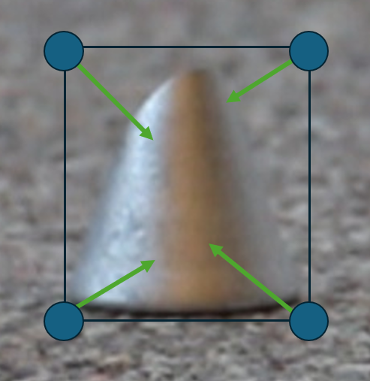

Figure 17: Diagram of corner points on a detection

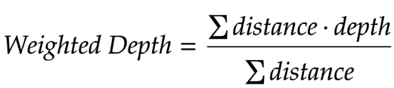

Figure 18: Math of the weighted depths of the corner points

We take a detection of the object on the Auxiliary Camera and convert it to the Depth Map. Instead of getting the depth of the object itself, however, we find the depth of the four corner points of the bounding-box. Each corner point weighs all the depths inside the bounding-box from their distance to each point, then normalizes the values. Using those four depths, we can derive their points in a 2d plane with relative positioning.

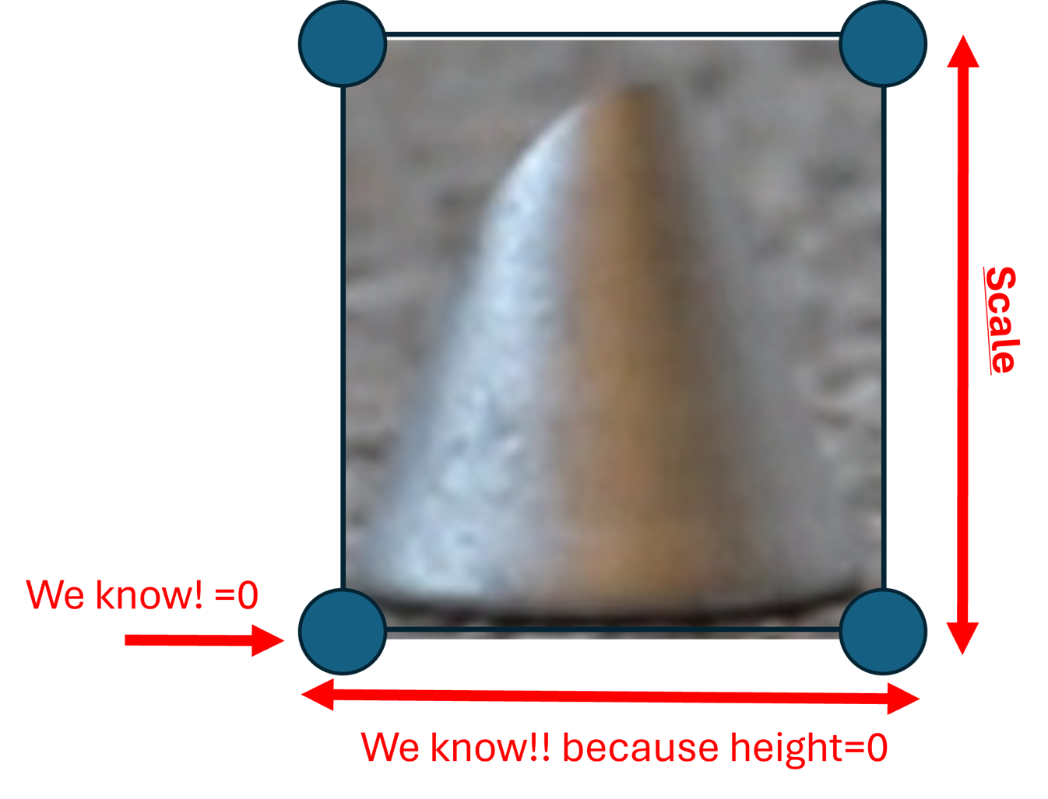

Figure 19: Diagram of the scaling of the corner points

However, these points in the second dimension are flat on the tarmacs surface, so converting them to Relative points in three dimensions is necessary. For the corners on the bottom, conversion is unnecessary, its z value is 0. Since we do not have a gyroscope on the Stereo camera to accurately calculate the z value for the top corner points, we have to derive it some other way. Given that we know the z value for the bottom points, we also know the distance between them is fine to take without any adjustment. We can at best use this distance and scale it to the distance between them pixel-wise and use that rate on the side length of the box to use as the z value for the top points. Now we have four three dimensional coordinates.

From here we can find the area of the plane the coordinates made by the sum of the two possible triangles between them.

### Dataset Collection

We use two separately trained ‘small-sized’ YOLOv8 models for both the Stereo Camera’s Auxiliary Color Camera and the Telescopic.

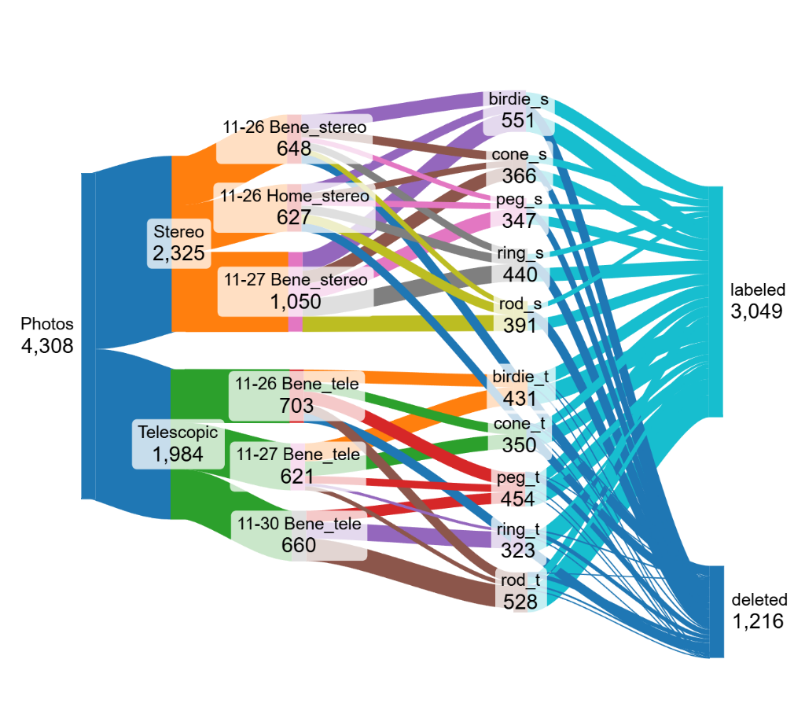

Figure 20: Flowchart of the Datasets

The two datasets collected for both models totaled 3049 images. 2095 Images for the Stereo Camera’s model and 954 images for the Telescopic Model. They were taken to classify 5 types of objects spray painted silver:

* Birdie, a broken [Finch Robot](https://www.birdbraintechnologies.com/products/finch-robot-2-0/)
* Cone, a cone with a cut on the top
* Peg, a short hexagonal peg
* Ring
* Rod

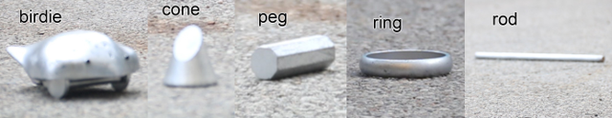

Figure 21: Collage of the five classified objects.

My goal was to collect a decent sized number of objects all with different shapes yet shapes not completely alien to each other to see how well the model could identify small differences within their shapes.

In data collection there was a large focus on having the objects in different parts of the frame, being in different orientations horizontally rotationally both upright and on its side. After some initial images were taken to give the model an understanding of the objects by themselves, unwanted objects like people were left in proceeding data collection.

[Here is a sped-up video of all the data being collected.](https://drive.google.com/file/d/1t2cNZFKZ_THwVVuUPOEwPz7jCrAfmx1k/view?usp=sharing)

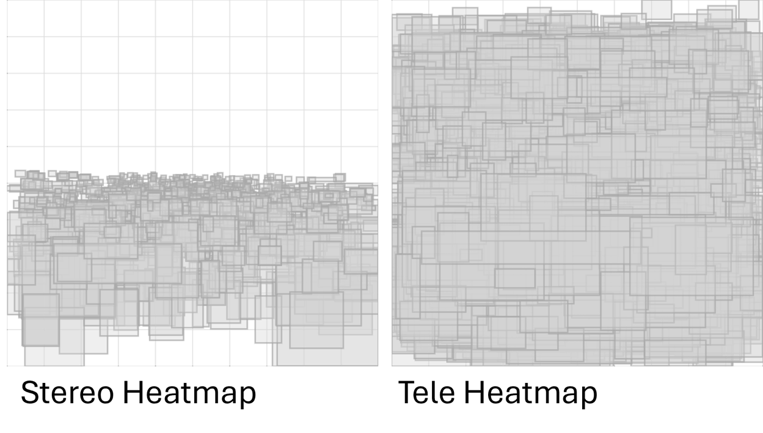

Figure 22: Heatmap of labeled dataset; Stereo (Left), Telescopic (Right)

### YOLOv8

YOLOv8 CNN Models were used and then retrained with the dataset. However, to better utilize for our use case, a container was made as a part of the system architecture. This architecture does things like search for the most recently created .pt or .onnx model if given a directory in place of the model file path in initialization, exports only important information to our use case when running on an image, and many edge cases involving model types or specific hyperparameters of the YOLOv8 model.

### ONNX models

Exported models from YOLOv8 are PyTorch with a ‘.pt’ filetype. These contain a lot of overhead information, and when a prediction is run on them most of the runtime is dedicated to this overhead. However, a lot of this overhead isn't important to our application so is best removed. Converting it to a different type of model called ONNX rips out all the overhead and uses just the bare weights.



Figure 23: Runtime of PyTorch Model on a dedicated server



Figure 24: Runtime of ONNX Model with own overhead on dedicated server

From the figures you can see that the Runtime is 300x faster on the ONNX model compared to the PyTorch model. However, without the overhead its prone to duplicate detections. So, our own overhead is required.

To prevent duplicate detections, we compare all bounding-boxes. We find pairs of boxes where they:

1. Have each of their corner coordinate points within a set distance of each other
2. Have an overlapping area percentage above a set percentage

If they fall under both assertions, we can assume they are similar enough to be duplications.

After collecting groups of duplicate detections, we can find the average of all the coordinates and have them as separate detections.

The optimization required to find the best set values wasn’t something that could be solved in time with the other computer vision developments, so this was scrapped, and we just used the initial PyTorch models. But it would be used in the future if this project was continued.

### Finite State Machine

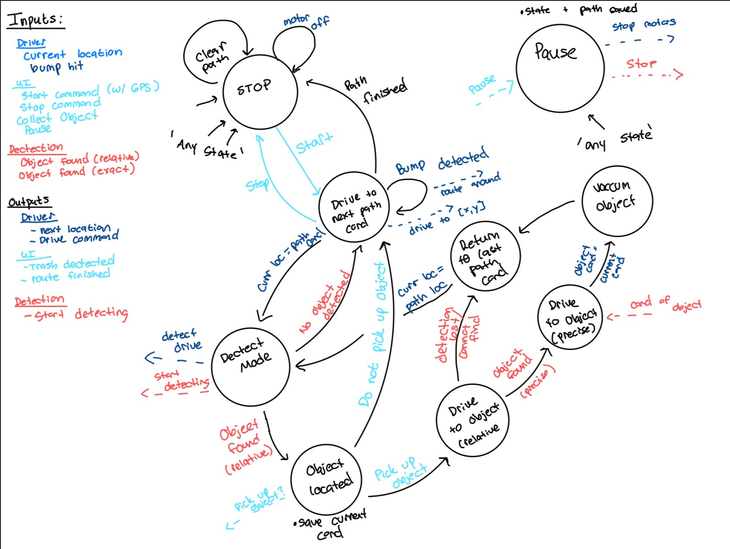

Figure 25: Finite State Machine Diagram

The Finite State Machine is our primary form of control on our entire bot. Based on the inputs from our motor driver (Current location), the UI (start, stop, pause), and the computer vision model (trash detection) it shall decide how the robot proceeds. It gives all motor controls and provides safety critical responses. It will cover edge cases such as the computer vision losing sight of the trash or the motor driver not being able to arrive at the right location.

### User Interface

The UI shall be built in python and be able to run on a MacOS or Windows machine. It connects to the bot via a Bluetooth connection. It allows the user to remotely control the bot so that they can start, stop and pause the bot. The user can also input 4 GPS points that act as a bounding search area. These points are passed along to the path planner for path generation. The UI is also capable of notifying the user when a piece of trash is detected.

### Path Planning

Path planning shall take an input of 4 gps points and translate them to relative {x,y} in meters, with the first GPS point being {0,0}. It will then generate a polygon path for the bot to follow, the path shall have periodic equidistant stops for trash detection. The path shall begin and end at the same point. The path should not intersect the area being searched and should be robust enough to handle edge cases.

## Hardware and Peripherals

### Arduino Mega

The Arduino Mega was used for both motor control and passing messages from the UI to the Jetson. The Arduino was chosen due to familiarity and ease of access. We had intended on using an ESP32, however it gave us troubles in the beginning and the Arduino had most of the capabilities we desired.

### Bluetooth Module

For a Bluetooth module we decided to go with HC-10 connected via serial to the Arduino mega. The HC-10 was our choice because of its simple nature and ease with integration into the Arduino. Because it acts as a serial port on the Arduino side, the software to implement it was easy. In addition, it was compatible with Bluetooth on laptops.

### Jetson Orin

The Jetson Orin was chosen for running our YOLOv8s models due to its powerful GPU acceleration and being optimized for deep learning tasks. The Jetson Orin is designed for real-time inference for object detection and tracking. It supports TensorRT optimization, significantly improving the efficiency of YOLOv8 by accelerating inference and reducing latency. Additionally, the device is energy efficient making it well suited for operation on our battery powered robot.

### Cameras

#### Telescopic Camera

The Telescopic was a Rebel T6i DSLR with a zoom lens that could go up to a 135mm focal length. We converted it to a webcam with a max size of 6000x3000 but limited it to 1920x1080 for computation regions. It had a sightline of 45” to 200” with a Horizontal FOV of 20 degrees at its max 135mm focal length.

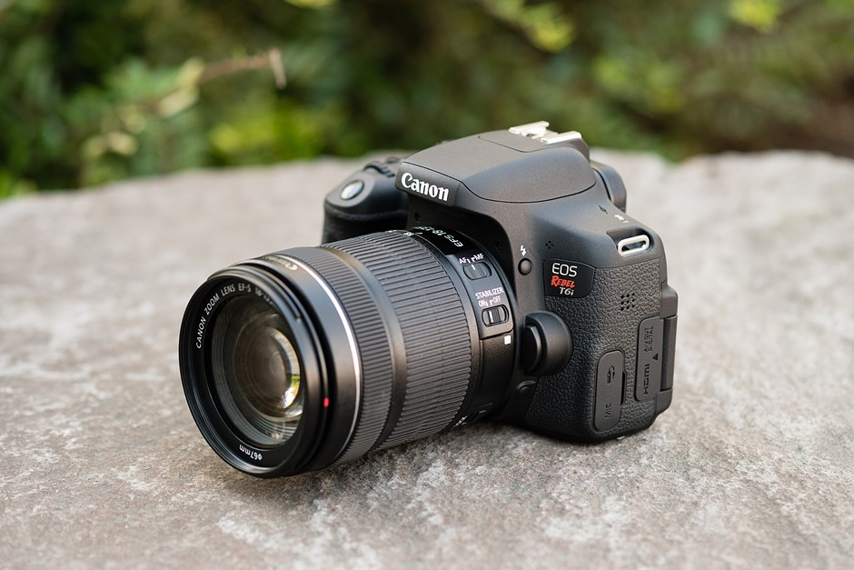

Figure 26: Rebel T6i DSLR Camera

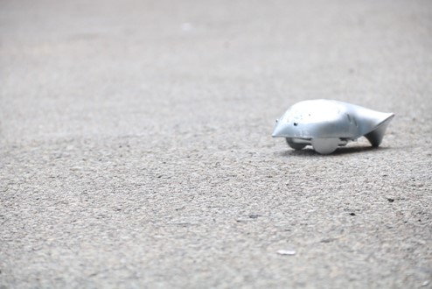

Figure 27 : Image off the Telescopic Camera

#### Carnegie Robotics KS21i Multisense Camera

The Stereo Camera is a Carnegie Robotics MultiSense KS21i. It has two Mono-Chromatic Cameras to the left and right side it uses to calculate a disparity map in the perspective and then convert it to a depth map. This is in a max size of 1920x1200, however for computation purposes we reduced the dimensions to 960x600.

The Auxiliary Camera has a 137-degree HOV and an 83-degree VFOV. The Mono-Chromatic Cameras has a 135-degree HFOV and an 84-degree VFOV. Any usage between the two cameras took this difference into account.

The Stereo Camera also has an Auxiliary Color Camera on the left side, 34mm to the right of the Left Mono-Chromatic Camera the depth map is in the perspective of. This is the Camera we do detections on for the Stereo Camera.

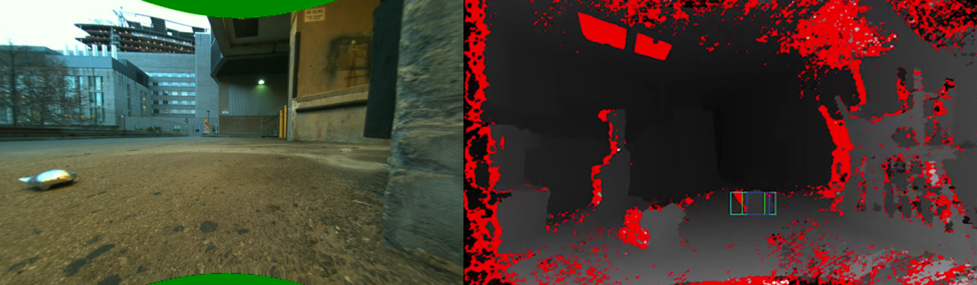

Figure 28 : Images off the Stereo Camera; Left: Auxiliary Camera; Right: Depth Map

Note: Images are not from the same instance

For testing purposes to better understand the Depth Map, the values have been normalized between its min and max float values between 0 and 255 to display. Null values, where the Mono-Chromatic Cameras are unable to identify disparity, have been made to a bright red.

## Motor Control

### Commanding the ESC

The ESC is controlled using the built in servo library for Arduino. This library uses hardware timers to output PWM signals so the microcontroller can continue to operate and perform tasks while waves are sent. The ESC is calibrated by sending a neutral, high, then low signal. This calibration is run during the setup function when the Arduino begins to run.

### Drive control

The bot is told distances and angles or XY coordinates from the Jetson via the FSM. Running on an Arduino Mega 2560 Rev3, the program calculates the amount of rotary encoder steps it must travel to reach the target distance. The program also sets the commanded steering angle. When commanded an XY coordinate the program uses the bicycle model to calculate the distance and angle it must travel to reach the target destination. A separate implementation of the bicycle model is used depending on if the bot is driving forwards or in reverse. An inverse bicycle model is used to calculate the position of the bot after it drives if commanded a distance and angle.

Upon receiving the RC car, we were told that the car had 2 brushless DC motors. This led us to the decision that we would be able to accurately control the distance traveled of our bot by moving at a constant rate and keeping track of the time spent moving. However, during the development of the project we realized that they were brushed DC motors and timing based control would not be good enough. We decided to attach a KY-040 rotary encoder to one of the rear wheels to keep track of rotations. The encoder steps would then be used in calculation to find distance traveled.

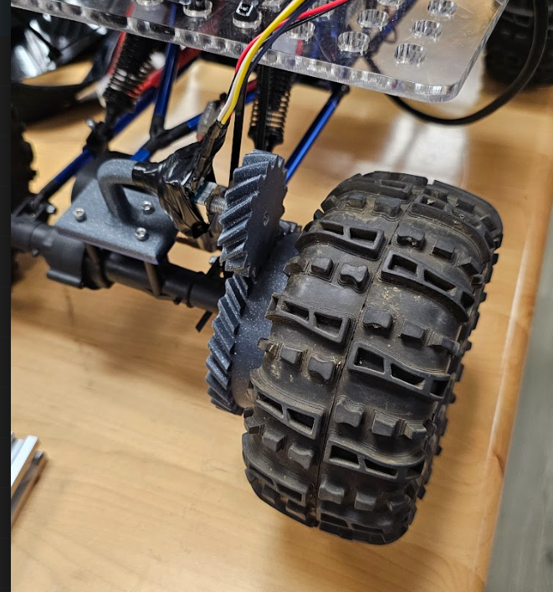

Figure 29: Rotary Encoder

Bump sensors were implemented using limit switches and a hardware interrupt as an emergency stop for our bot. If any of the limit switches were triggered the bot would instantly stop and send a kill command to the Jetson. This was to ensure that if the bot were to collide into anything while out on the runway that it would not continue moving and become a piece of FOD itself.

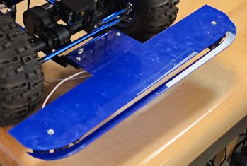

Figure 30: Bumper sensor

## Chassis

### Production and Fabrication

The main chassis running chassis was supplied by RAS. To attach all of our components a ¼ inch panel of acrylic was used as base. The base featured a grid of 1cm holes that could be used for mounting. Custom 3D printed brackets were designed to hold everything to the base securely. Components that were not held using 3D printed mounts were held on using zip ties or other methods of adhesion.

During testing we discovered that the center of gravity was too high and that when the robot turned all the components on top would lean. To prevent this, we first set the ride height to the maximum setting then used zip ties to place the body under tension. This prevented the leaning while still allowing our suspension to travel and absorb imperfections in the road.

After our initial testing with the bot, we discovered that the stereo camera was mounted too low for it to be able to make a useable depth map of the space in front of it we had to modify the original setup and swap the locations of the cameras to get the height we needed.

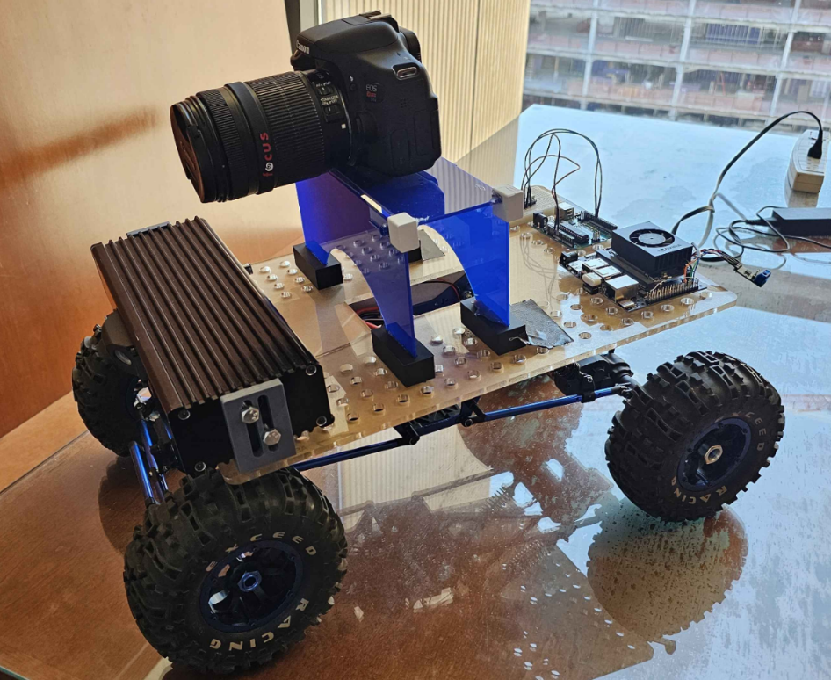

Figure 31: Chassis Version 1

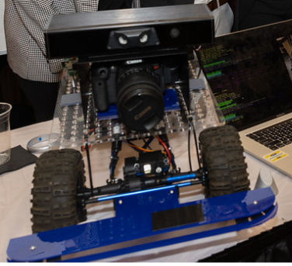

Figure 32: Chassis version 2

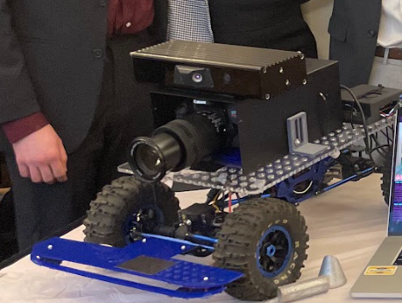

Figure 33: Chassis Version 2

# Team and Timeline

## Team

### Lauren Gilfillan

Lauren will oversee the user interface and its communication with the bot. The user interface will be a laptop-accessible phone app that can control the robot to start and stop. She will also oversee the Bluetooth communication from the UI to the Arduino. Lauren will work on building and integrating module all together. This ties in directly with her development of the Finite State Machine that runs the overall bot. Finally, Lauren will generate a program to generate a path from GPS points into local {x,y} points

#### Skills learned in ECE coursework

* Embedded Systems and Project Management from ECE1895
* Applied Embedded Systems in ECE1188
* System Engineering from ECE1140
* Path Planning and Robotics Control from Cyber-Physical Systems

#### Skills learned outside ECE coursework

* In previous internships, I worked on embedded robotics, so I have experience with complex integration experience and navigation.
* Because of our industry connections to Carnegie Robotics, we will be consulting them on our robotic design.
* We will be utilizing our friends in RAS because they have a lot of experience working with these kinds of robots.

### Jonah Belback

Jonah will be responsible for Computer vision including ML object detection, object coordinate mapping using the camera’s depth map, and any image processing required to clarify the camera’s image. He will also be responsible for the Code Base and architecture of the Jetson executing modules and communication to the ESP32.

#### Skills learned in ECE coursework

#### Skills learned outside ECE coursework

##### Skills

* Image Processing, Embedded Systems, System Engineering, Robot Autonomy, Software Architecture, and Project Management, from Pitt Robotics Club ‘Sailbot’.
* Research, Expo Presentation, Parallel Processing, and Creating Applications in large pre-existing Frameworks from SHREC’s SURG 23’ under Dr. Alan D. George.
* Machine Learning in LLMs from SHREC’s SURG 24’ under Dr. Alan D. George.
* API Interfacing, Professional Documentation, and R&D Verification from Ansys Co-op.

##### Resources

* Ultralytic’s YOLOv8n and their tutorials; ML Object Detection [S3]
* Roboflow’s dataset creator [S4]
* History of System Engineering, plenty of old stable containers to reference from [S5]

### Chad Collina

Chad will be responsible for controlling the robot. This includes following the designated route, navigating around obstacles, deviating from the path to pick up debris, and returning. Chad will also be responsible for all the 3D modeling and mechanical design required to make our prototype functioning.

#### Skills learned in ECE coursework

* Robotics control in ECE1188
* System design in ECE1140
* Embedded systems programming and architecture in ECE1895 and ECE1175

#### Skills learned outside ECE coursework

* 3D modeling in MEMS0022
* General design and fabrication from personal projects (laser cutter, 3D functional prints)

### Justin Lipner

As the only electrical engineer on the team, Justin was responsible for ensuring all the power requirements are met, all components are electrically protected where needed. He was also responsible for all circuit simulations, breadboard prototypes relating to the PCB, and PCB design/assembly.

#### Skills learned in ECE coursework

* PCB design for slot machine in ECE1895
* Learned how to solder in ECE1890
* Power and circuit basics from ECE101, ECE102, and ECE1701

#### Skills learned outside ECE coursework

* Redesigning a new robot for ECE1188 taught me how to make components in Altium, how to make PCBs with multiple layers, and how to choose components based on some goal/constraint. I created power distribution and motor control circuits for the robot.
* I took a Power Electronics course on Coursera alongside this class.
* The electronics class taught by Jim Lyle in SERC taught me how to read complex schematics, identify components on a PCB, and how various electronic components work. Additionally, Jim also taught me how to solder surface mount components.

## Timeline

|  |  |
| --- | --- |
| Week | Completed Goals |
| *8/26 - 8/30* | **All -** Presented Ideas |
| *9/2 - 9/6* | **All -** Schedule created, conceptual design done, email about changes |
| *9/9 - 9/13* | **Lauren –** Generate Path Planning Code, Establish Ros Code  **Chad -** Chassis selection  **Justin -** Power distribution and battery research.  **Jonah -** Research Datasets, YOLO model (tiny?), fisheye lens correction, data: distort images to the same way as a camera; Make example ML Mode.  **All -** Work on Conceptual Design Guide |
| *9/16 - 9/20* | **Lauren -** Ordered Bluetooth Module, Start UI Interface  **Chad** - 3D modeling brackets and mounts  **Justin -** Component research.  **Jonah -** Class Diagrams, Model Container creation, Start working processing ML on Jetson  **All -** Conceptual Design Guide DONE (for the most part) |
| *9/23 - 9/27* | **Lauren -** Started working on the UI interface  **Chad –** Establishing ESC communication, Discovered steering power servo problems  **Justin -** Begin PSpice Simulation for the power system.  **Jonah -** Camera Testing; Training real model if possible, Optimizing Model, Photo Data collection  **All -** Nothing Specific  Conceptual Guide Due |
| 9/30 - 10/4 | **Lauren –** Pivoted to different UI Interface  **Chad –** Figuring out steering servo power issues  **Justin -** Finish LTSpice simulation for the power system.  **Jonah -** Camera Testing; Optimizing Model  **All -** Nothing Specific |
| 10/7 - 10/11 | **Lauren -** Debugging Bluetooth connection and UI  **Chad –** Production and Fabrication of bot  **Justin -** Breadboard prototype for reverse current protections.  **Jonah -** Model(s) is training DEADLINE (possibly with CRC); work on depth map point function or crop/reduce func  **All -** Nothing Specific  Checkoff #1 Due |
| 10/14 - 10/18 | **Lauren –** Building Python FSM  **Chad –** Gathering timing table information, tuning linear interpolation  **Justin –** Begin PCB design.  **Jonah -** Work on depth map point function done; crop/reduce function done; Jetson Architecture, ESP32 Communication  **All -** Nothing Specific |
| 10/21 - 10/25 | **Lauren –** Testing FSM  **Chad -** Begun IMU testing  **Justin -** PCB design finished, and PCB ordered.  **Jonah -** Work on Architecture and ESP32 Communication if not already  **All –** Intergration w/out PCB  Midterm Presentation |
| 10/28 - 11/1 | **Lauren –** Fixing FSM and Bluetooth  **Chad -** Ditched IMU and moved to 3D modeling laser cut gears for encoder transmission  **Justin -** PCB assembly/testing.  **Jonah -** Focus on Architecture  **All –** Integration w/ PCB |
| 11/4 - 11/8 | **Lauren -** Fixing UI  **Chad –** Pivoted to larger external gears, not enough space in wheel hub. 3D modeled and printed transmission and mount for encoder.  **Justin -** PCB redesign.  **Jonah -** Focus on Architecture  **All -** Minimum Viable Prototype Done |
| 11/11 - 11/15 | **Lauren –** Providing Support with continued integration  **Chad -** Printed gears and attached to bot  **Justin -** Test 2nd version of PCB.  **Jonah -** Focus on Architecture; work on other modules if not completed  **All -** Nothing Specific |
| 11/18 - 11/22 | **Lauren –** Generating Presentation Material and support with continued and integration  **Chad –** Encoder testing, linear interpolation  **Justin -** Help assemble the final prototype  **Jonah -** Architecture is stable deadline  Checkoff #2 |
| 11/25 - 11/29 | *Thanksgiving Break* |
| 12/2 - 12/6 | **Lauren -** Generating presentation material / Testing  **Chad -** Generating presentation material / Last minute debug  **Justin -** Generating presentation material / Last minute debug  **Jonah -** Generating presentation material / Last minute debug  **All –** PROTOYPE FINISHED  Final Presentation  Design Expo |
| 12/9 - 12/13 | **Lauren -** Finish Final Report  **Chad -** Finish Final Report  **Justin -** Finish Final Report  **Jonah -** Finish Final Report  **All -** Pray some more  Final Documentation Due |

# Testing Procedures

## Hardware Systems

### Buck Regulator

Expected Behavior: The output voltage from the TPS54550 should be around the designed value of 9V with an acceptable output ripple.

Testing Procedure: Measure the output voltage with a multimeter and oscilloscope to determine how close the real output is to the designed value.

### Reverse Current Protection

Expected Behavior: The PCB should have no negative response in the event the battery is connected backwards, and once the battery is connected correctly, the PCB should work as intended.

Testing Procedure: Connect the battery in reverse and observe the PCB’s reaction. Then connect the battery correctly and observe the PCB’s reaction.

### PCB Stress Test

Expected Behavior: The PCB should function under absolute max load.

Testing Procedure: Run the max possible load on the Jetson and observe the effects this has on the PCB.

### Battery Life

Expected Behavior: The Battery should last at least 1 hour before needing to be recharged.

Testing Procedure: Operate the robot and see if the battery lasts an hour.

## Software Systems

### Computer Vision

#### Depth

Expected Behavior: The Stereo Camera gives an acceptably accurate measurement of Depth of an object

Testing Procedure:

1. Mark a straight line on the ground and place the Stereo Camera on said line with an intersection of its Left Mono-Chromatic Camera where the depth map is in the perspective of.
2. Plant an object on the line ahead of the Camera
3. Take measurement of the distance of the object from the camera in reality and a calculated measurement off the camera.
4. Slightly move the object backwards
5. Repeat steps 3 and 4 until you've covered the entire length of the line
6. Compare results

#### Relative Positioning

Originally when we planned around having a gps to track our position we were going to hand off the relative position of the object calculated with its depth and angle rather than the depth and angle itself.

To test how the calculated depth and angle calculations work, however, metrics in Relative Position is a great method so we proceeded with some testing in it anyway rather than just angle.

Expected Behavior: The Stereo Camera gives an acceptably accurate measurement of a calculated Relative Position of an object

Testing Procedure:

1. Mark a straight line on the ground and place the Stereo Camera on said line with an intersection of its Left Mono-Chromatic Camera where the depth map is in the perspective of.
2. Mark lines coming off the central line in perpendicular
3. For each perpendicular line:
   1. Place an object on one end of the perpendicular line
   2. Take measurement horizontally and vertically of the Relative Position of the object from the camera in reality and a calculated Relative position off the camera.
   3. Move object slightly to the side, still on the line
   4. Repeat steps 3.2 and 3.3 until you've taken a measurement of an object across the whole line
   5. Move to the next perpendicular line.
4. Compare results

#### Models

Expected Behavior: Model for both Telescopic and Stereo is accurate and fast

Testing Procedure:

1. Create a Dataset with the images the normal sized the cameras operates at
2. Label Dataset, save separately
3. Alter original dataset so image dimensions are a reduced and devisable by 32, save separately
4. Alter original dataset so image dimensions are square to specifically 640x640, save separately
5. Train a Telescopic Model and Stereo Camera Model from each type of dataset for an hour, exit before the next epoch.
6. Compare all the model's runtime and accuracy to obtain the best configuration of the data for the most effective results.

### Motor Controls

#### Straight line precision driving

Expected Behavior: The bot drives in a straight line the correct distance it is commanded

Testing Procedure:

1. Place the rear wheel of the bot against a backstop to ensure the bot is starting from a consistent location.
2. Command the bot to drive with no steering angle a distance of [10, 30, 60, 120] inches.
3. Measure and record the distance traveled based off the front axle.

#### Returning to home testing

Expected Behavior: The bot leaves from its current position, reaches a target position and returns back to where it started.

Testing Procedure:

1. Mark the starting position of the center of the front axle.
2. Command the bot to drive at a [10,15 20] degree angle and 80 inches forward.
3. After reaching the target destination the bot will pause then reverse back to the location at which it started.
4. Once it has returned, measure and record the distance and angle from the marked origin.

#### Bump Sensor Collision detection

Expected behavior: The bot should stop after detecting a forward collision.

Testing Procedure:

1. Support the bot in the air so that the wheels are not touching the ground
2. Command the bot to drive indefinitely.
3. Press firmly on different positions of the bumper. Press only once and listen for an audible click.
   1. If there is no click after pressing the trial failed.
   2. If there is a click and the wheels do not stop turning the trial failed.

### FSM

#### Edge Case Test

Expected behavior: Utilizing the directed-edge graph generated, ensure the finite state machine can follow all paths as the design intended

Testing Procedure:

1. For each state possible {0,9}
   1. Begin the finite state machine and other associated peripherals
   2. For each potential ‘in-state’ (a state in which has a direct arrow into the state we are testing), iterate a path over the FSM and ensure the FSM can get from the in-state to the state being evaluated with expected input from peripherals
   3. For each potential ‘out states ensure that the FSM is able to transition from the evaluated state to the test state with the expected input from peripherals
   4. Note any failures, unexpected exits, and unplanned paths being taken

#### Finite State Machine – Latency Test

Expected behavior: Ensure that the FSM transitions between states on average in less than 10 ms to ensure a real time system. Note – this is not an evaluation of how much time is spent in certain states, as this is variable based on the detection algorithms and driving capabilities. But the speed of the program to transition out of one state into another.

Testing Procedure:

1. Upload special FSM with transition time recording onto Jetson
2. While running the FSM with all peripherals running (for the most accurate testing), iterate over several random paths in FSM, noting which state transitions were taken
3. Export file of transition timing and generate comparative chart. Observe the mean, variance, and outliers of the data set.

### Bluetooth + Arduino Communication Latency

Expected Behavior: Bluetooth should be able to deliver messages from the Python UI to the Jetson in under 100 ms in order to ensure a real-time system.

Testing Procedure:

1. Make sure both the Jetson and Laptop running the UI are time-synced clock wise
2. From the UI, generate python program to record when a Bluetooth message is sent
3. From the Jetson, generate a special program that records when messages are received (via Serial on the Jetson)
4. From the UI, send a variety of messages in a random order.
   1. Run this test without running an ML on the Jetson or Rotary encoders on the Arduino
5. Run the same test again
   1. This time, have the full peripheral load running on both the Jetson and Arduini
6. Offload Timing results from UI and from Jetson. Calculate the difference and calculate mean, variance, and outliers for the dataset

### Path Planning Generation

Expected Behavior: When inputted with 4 GPS points, the program shall generate a path in relative {x,y} that outlines the shape but does not intersect it. It shall not generate paths that do not have any area or have less than 4 corners.

Testing Procedure: Because it would be redundant to do a quantative test (since the equation used to convert GPS coordinates to local {x,y} is relatively simple). We want to test the ability of the program to make a reasonable path based on a variety of inputs and edge cases. To test the ‘reasonability’ of the path, we do a side-by-side comparison of GPS points mapped to the output of the path planning program graphed.

### UI – Usability

Expected Behavior: The user, with high level knowledge of the project, should find the UI usable and easy to understand.

Testing Procedure:

1. Taking a test subject, ask them to navigate the UI and try to accomplish the following tasks
   1. Connect to Bluetooth
   2. Input GPS Points
   3. Start the Robot
   4. Pause the Robot
   5. Stop the Robot
   6. Approve Trash Collection
2. After the user has done these tasks, ask them to rate the UI on the following metrics out of 10,
   1. Accessibility
   2. Easy to Understand
   3. Covers User Edge Cases

#### Path Planning Generation

Expected Behavior: When inputted with 4 GPS points, the program shall generate a path in relative {x,y} that outlines the shape but does not intersect it. It shall not generate paths that do not have any area or have less than 4 corners.

Testing Procedure: Because it would be redundant to do a quantative test (since the equation used to convert GPS coordinates to local {x,y} is relatively simple). We want to test the ability of the program to make a reasonable path based on a variety of inputs and edge cases. To test the ‘reasonability’ of the path, we do a side-by-side comparison of GPS points mapped to the output of the path planning program graphed.

## Testing Results

### Hardware Systems

#### Output Voltage

The waveform of the output voltage can be seen in the figure below. The PCB was designed for 9V with a 5mV ripple. As can be seen, we have a 20mV ripple. This discrepancy is most likely due to the higher ESR seen at the output from the electrolytic capacitors.

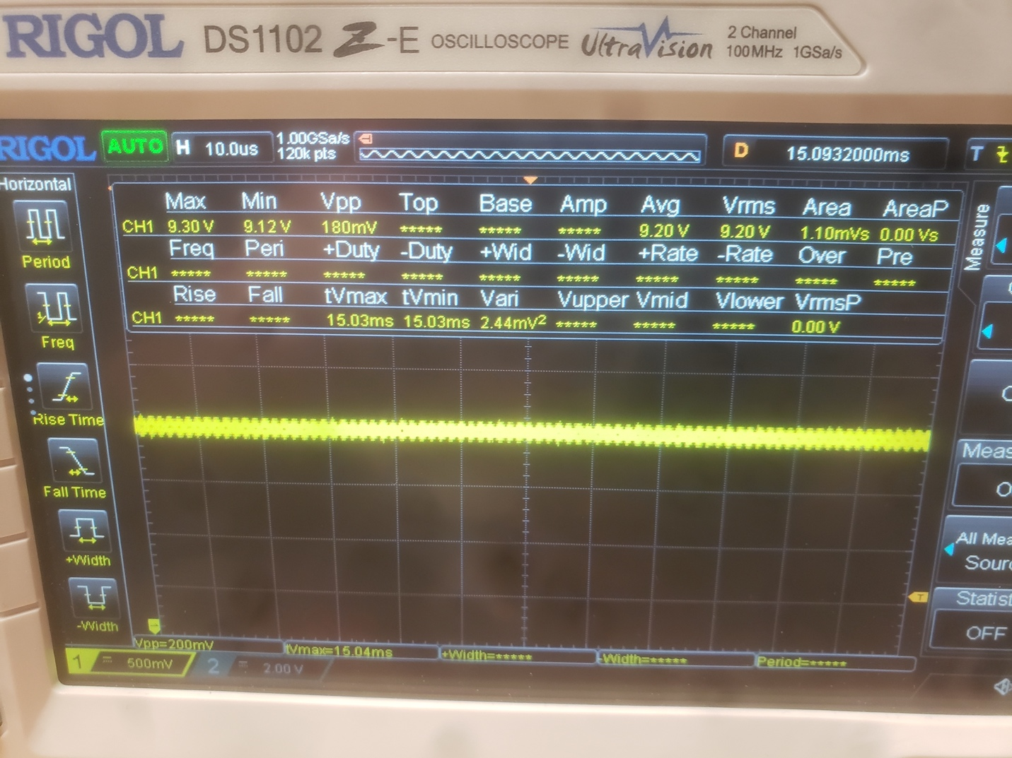

Figure 34: Output Voltage

#### Reverse Current

The battery was connected in reverse using the created power cables. As can be seen in the image below, the onboard LED is not on indicating no power is flowing through the board. Also, there are no signs of component damage due to the reverse connection.

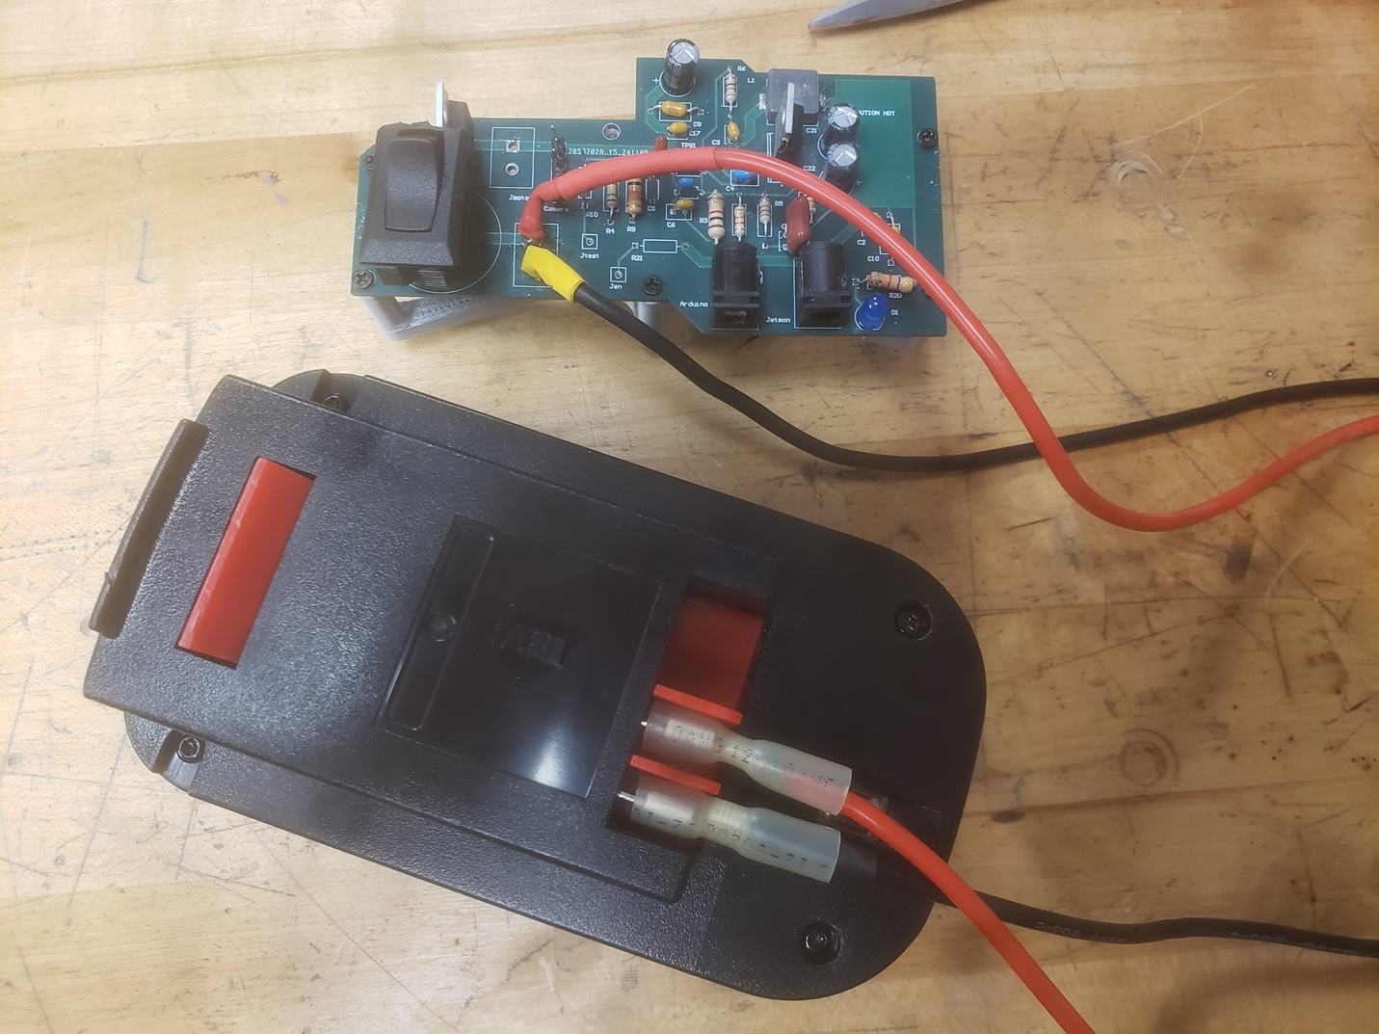

Figure 35: Reverse Current Protection

The next image shows the PCB working correctly after the battery is connected in the right way. The onboard LED is on, indicating that the PCB was not damaged in any way during the reverse connection.

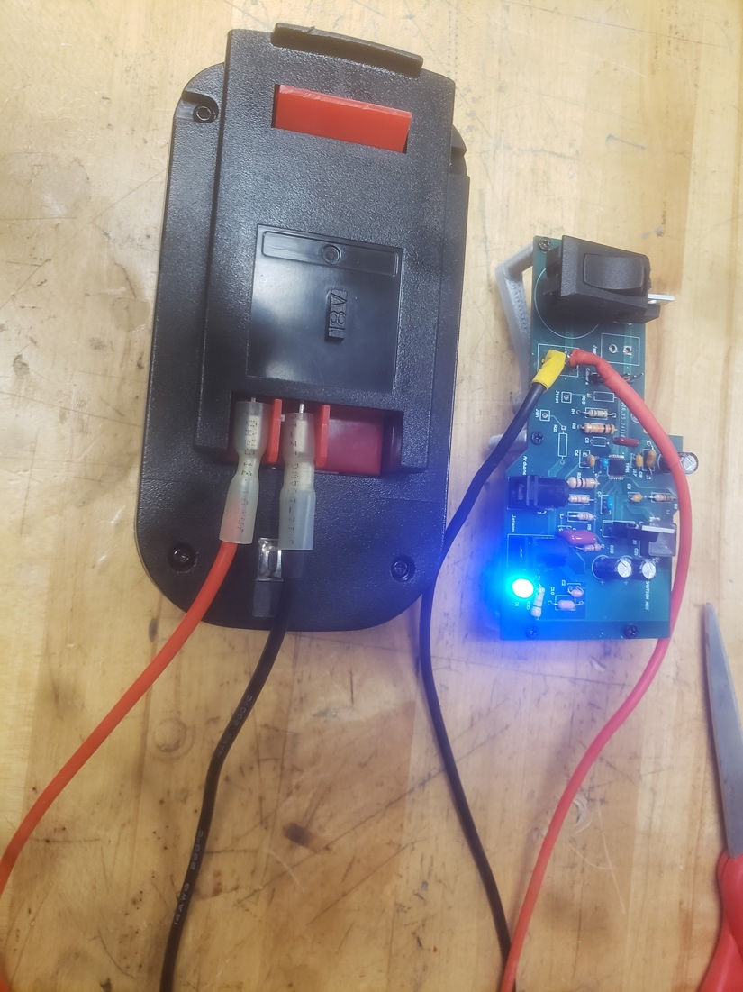  
Figure 36: Stress Test

#### PCB Stress Test

The PCB was stress tested by running a version of the software that processes data in real time at a pace that isn’t nominal. We did this to ensure the PCB held up in extreme conditions. The video below shows the camera and jetson being reliably powered proving the PCB had no issues meeting the load requirements. Additionally, we were concerned about the switching MOSFET frying itself, but no overheating issues were apparent during the test.

#### Battery Life

We chose a 6 Ah battery based on the Jetson’s max current draw of 3.5A through the barrel jack. Adding this to the max current draw from the Stereo Camera of 0.667A we get 4.17A. Adding 20% onto this as a good failsafe measure (recommended by Jim Lyle), we get 5A total. The Arduino’s current draw is negligible since it’s only being used to drive pins. Our battery will last for at least 1 hour if 6A of current is going through it, so our max expected battery life is well within this limit. We tested the robot “in the field” well throughout the last couple of weeks and the battery did last in every test case for at least an hour.

### Software Systems

#### Depth

We had issues with the default depth map coming from the camera, so we manually did the conversion from a disparity map. However, this was also off so we collected some metrics of real depth vs the calculated depth. We put down a line of tape on the floor coming off of the Left Mono-Chromatic Camera, the one where the depth map is in the perspective of, and took measurement of an object both on the feed and in reality.

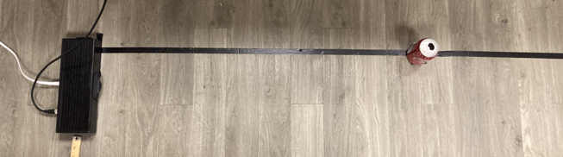

Figure 37: Testing Environment for Depth

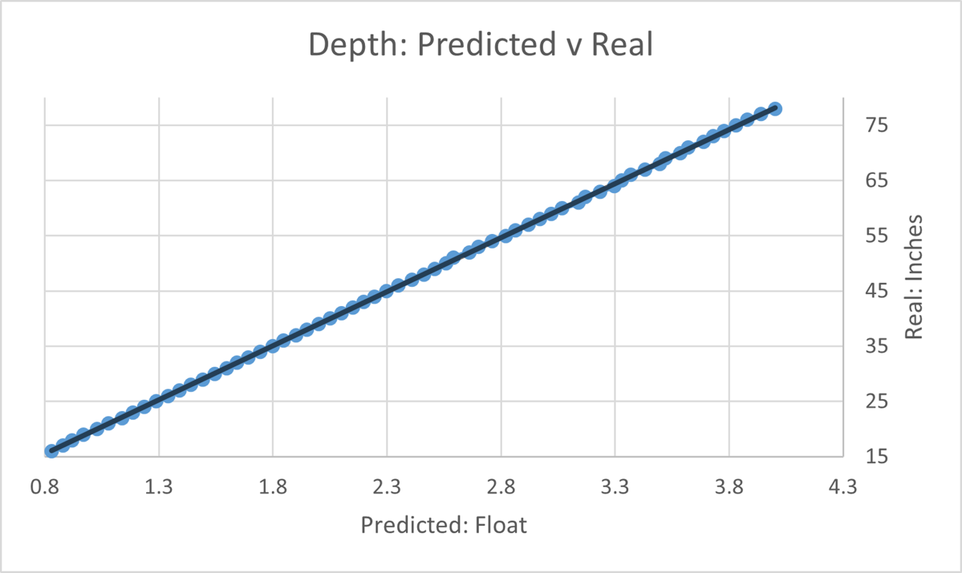

Figure 38: Relationship between Real Units and Calculated Values

Between Real Units in Inches and what the camera was calculating, it followed a linear relationship. We could take the average conversion of these and use it to properly convert out unitless calculated value to inches.

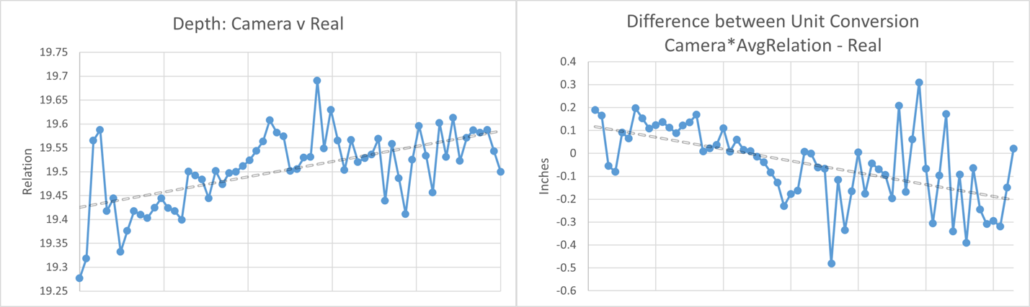

Figure 39: Real Units and Calculated Values mapped on a closer difference Relationship to better see deviations on its linearity

It's hard to see the deviations on the original line so these adjusted values make it more apparent. It varies off the conversion more as it gets further away, but it happens on both sides, so this seems like a best-case choice.

#### Relative Positioning

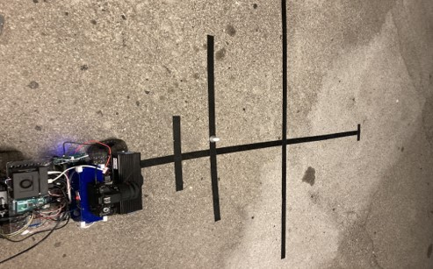

Figure 40: Testing Environment for Relative Positioning

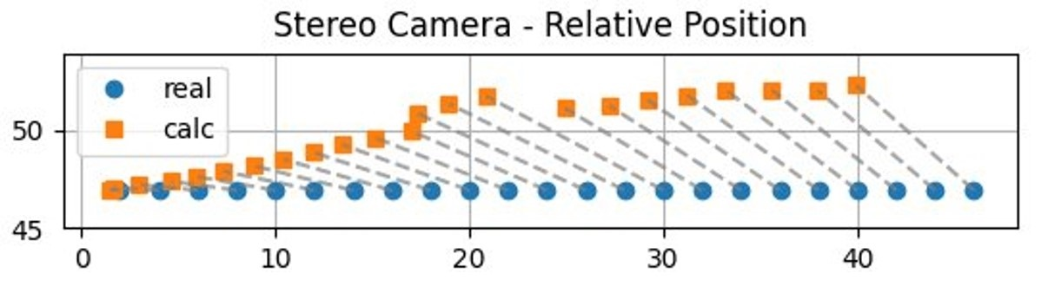

Figure 41: Relationship between Real Position and Calculated

Individual pairs are linked with a dashed line

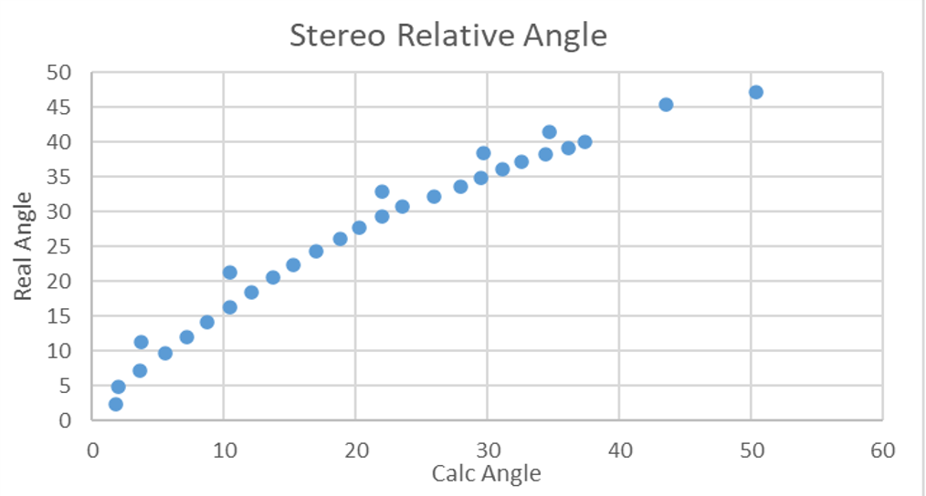

Figure 42: Relationship between Real Position and Calculated

Individual pairs are linked with a dashed line

Closer to when the angle is zero, and as the calculated relative position is based mainly on the calculated depth, accuracy to the real positioning is very high. As you get further to the side and the angle comes more into play, the accuracy drops, however. This is likely from the angle being off, specifically the Left Mono-Chromatic Camera and the Auxiliary camera’s horizontal position from the center not being considered.

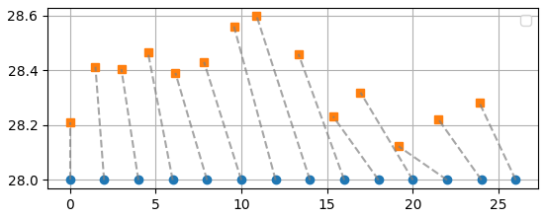

Figure 43: With Adjusted Consideration, Relationship between Real Position and Calculated

Individual pairs are linked with a dashed line

Here is another graph with such considerations taking place. The fact that a lot of the positioning doesn't pass any of the values on the x-axis means that the angle is still under shooting, however its more randomness also means that depth is now more at play in the miscalculation. So, this consideration is a success but not perfection.

#### Models

There was talk I saw on the GitHub forums about the performance of the YOLOv8 Architecture on different input sizes, so I tested training with three different image sizes datasets: Default size we had the camera at, a modified dataset the dimensions reduced and divisible by 32, and a dataset modified to be square. All the Models tested were only given an hour of training.

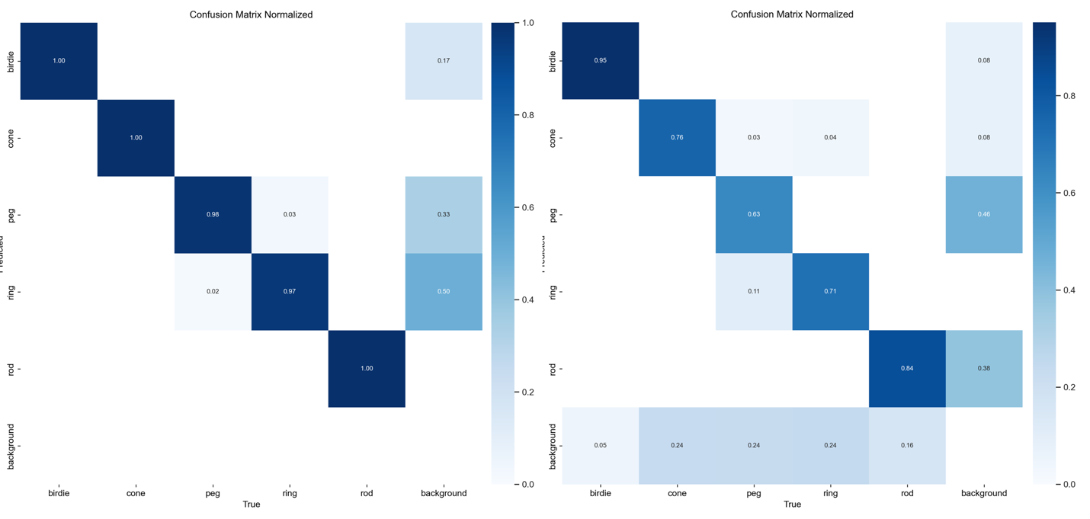

Figure 44: Confusion Matrix of Models using Default sized dataset  
Telescopic 1920x1080 (Left), Stereo 960x600 (Right)

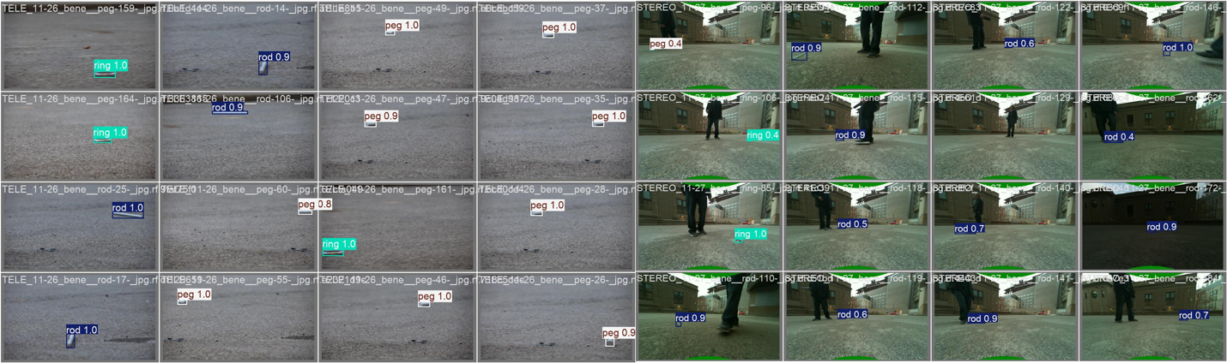

Figure 45: Performance Examples of Models using Default sized dataset  
Telescopic 1920x1080 (Left), Stereo 960x600 (Right)

The default input image sizes were differentiating decently well, as you’ll see in the other models the Telescopic Model is always especially good, but here it’s comparatively okay. The Telescopic Model had a runtime of 0.484 seconds on average, the Stereo Model had a runtime of 0.486 seconds on average.

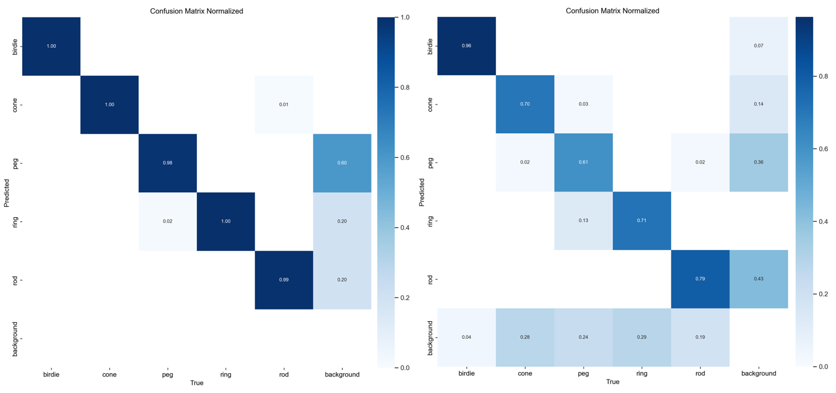

Figure 46: Confusion Matrix of Models using Reduced sized dataset  
Telescopic 960x544 (Left), Stereo 640x384 (Right)

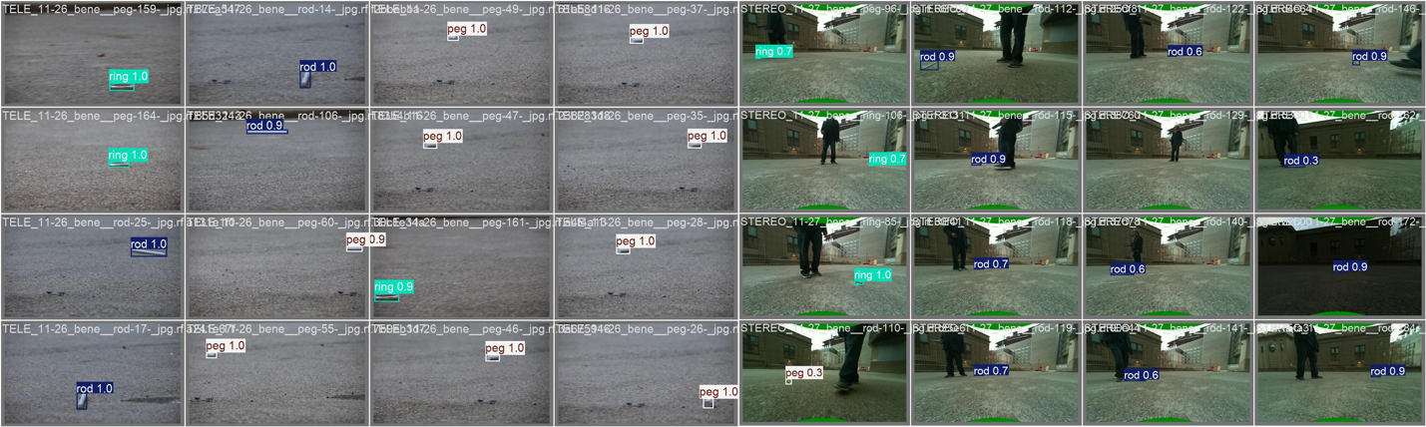

Figure 47: Performance Examples of Models using Reduced sized dataset  
Telescopic 960x544 (Left), Stereo 640x384 (Right)

These image sizes were reduced in size to test the runtime of the model and how much of a deficit it would have on the classification rate. The image sizes were also made to be divisible by 32 as I also saw on forum threads having a better performance.

Its classification was a little worse and a questionable runtime with the Telescopic Model having a runtime of 0.456 seconds on average, the Stereo Model had a runtime of 0.513 seconds on average. Telescopic barely improved in runtime while Stereo was actually decently worse.

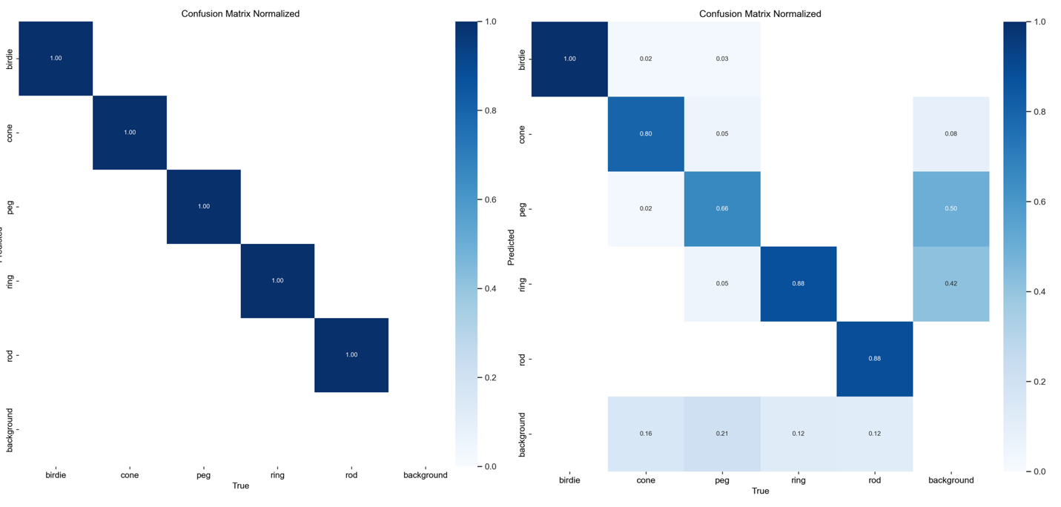

Figure 48: Confusion Matrix of Models using Square sized dataset  
Telescopic 640x640 (Left), Stereo 640x640 (Right)

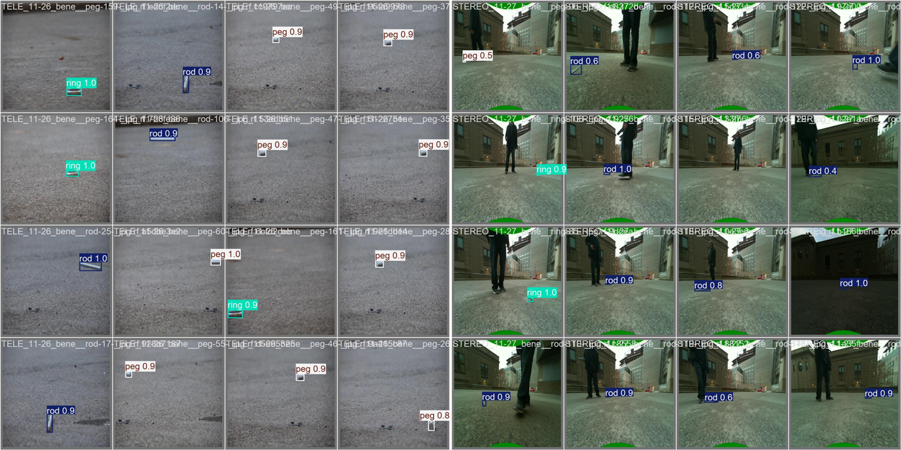

Figure 49: Performance Examples of Models using Square sized dataset  
Telescopic 640x640 (Left), Stereo 640x640 (Right)

These image sizes were reduced to be a square image, this 640x640 dimension is actually the default size and recommended of the YOLOv8 model. The Telescopic Model’s Classification was perfect with a 100% accuracy on never-before-seen images, The Stereo camera however has just gotten worse. The Telescopic Model had a runtime of 0.443 seconds on average, the Stereo Model had a runtime of 0.492 seconds on average. We decided to use the Squared 640x640 Model for Telescopic and the Default 960x600 Model for the Stereo Auxiliary Color Camera.

#### Motor Controls

##### Straight Line Precision Driving

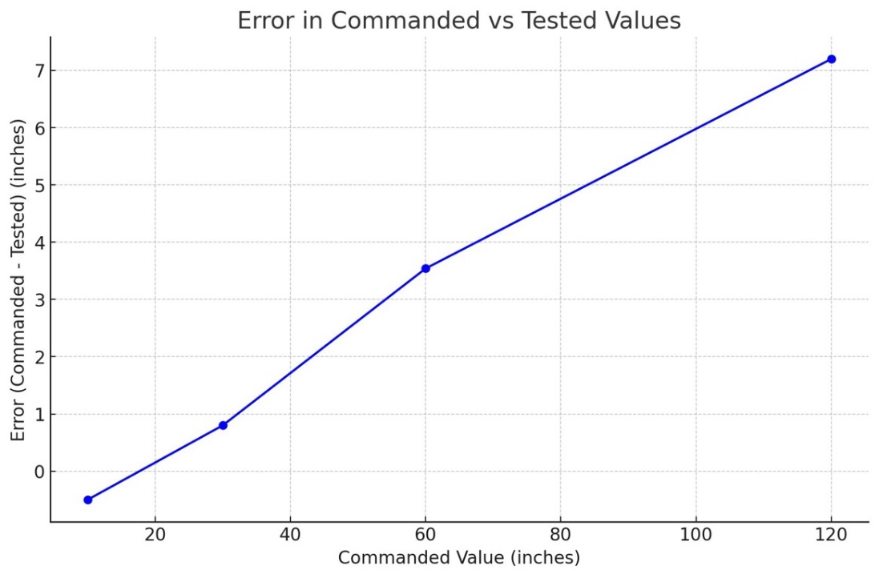

Figure 50: Distance Error

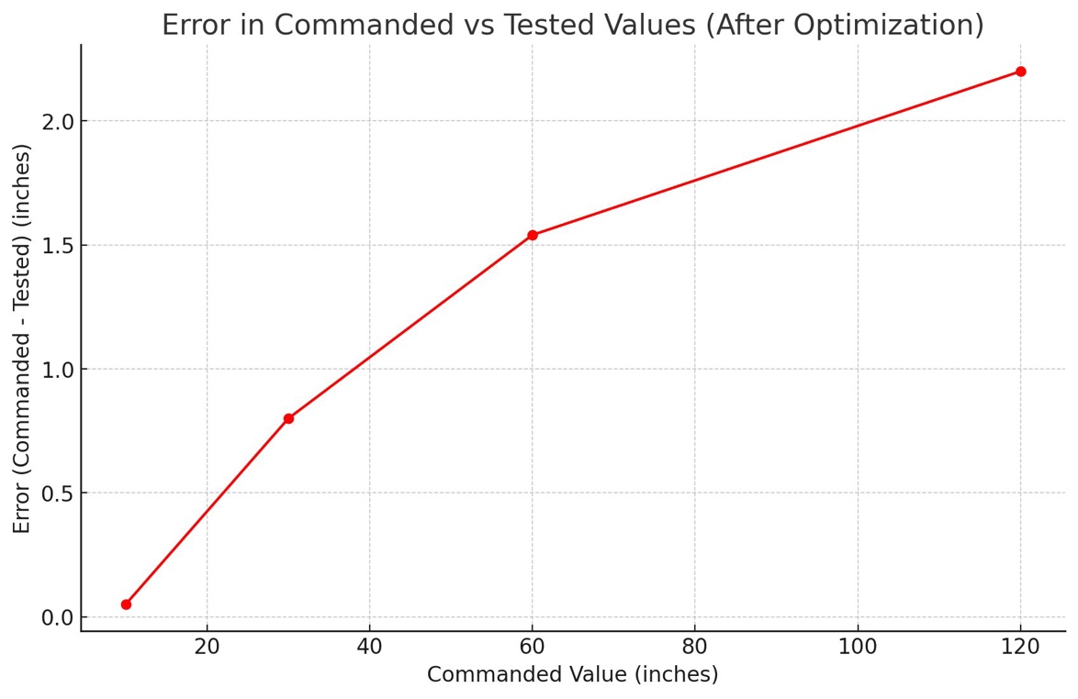

Figure 51: Post Optimization Distance Error

The top graph shows the results of my initial testing. Each test shows about a ±5% error on approaching the commanded distance. The results were quite promising, but I knew they could be improved upon. I used linear interpolation to calculate a modifier that would vary the number of steps commanded for more accurate travel. The final interpolation equation I settled on was

steps += (int)round((.03)*steps - 1.22);

This modifier gave me about ±1.7% accuracy. Achieving this level of accuracy was important because if we were to attempt to vacuum the debris, it ensured that we were on target, and it would be removed.

#### Return Home

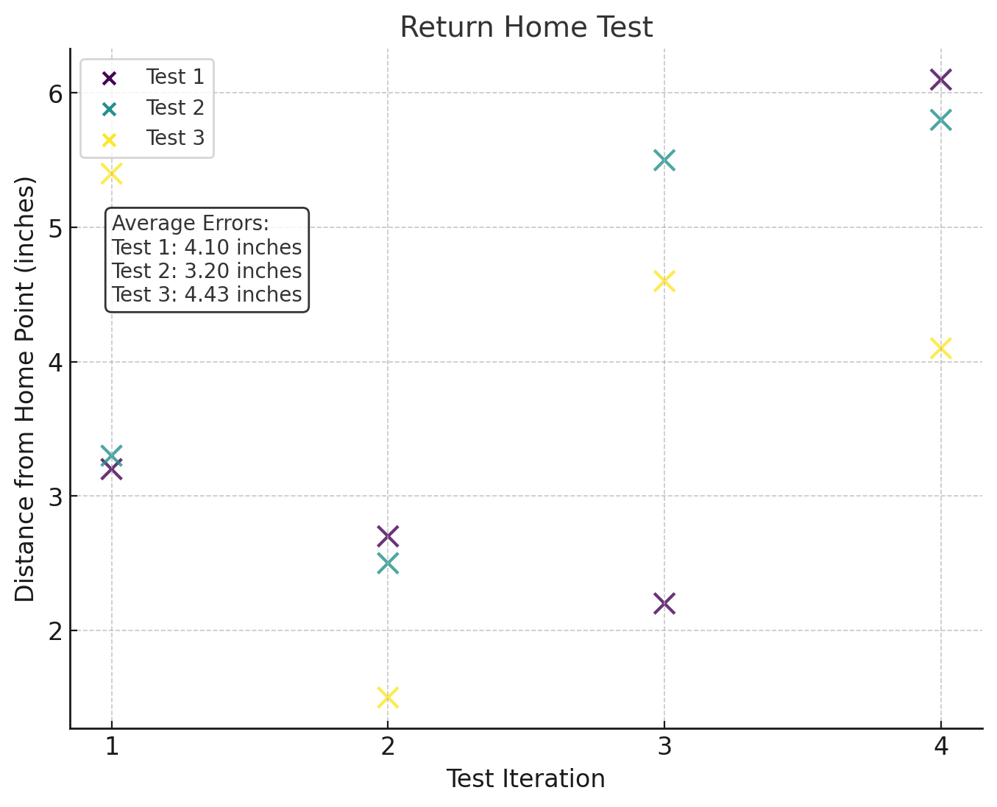

Figure 52: Return Home Test Results (distance)

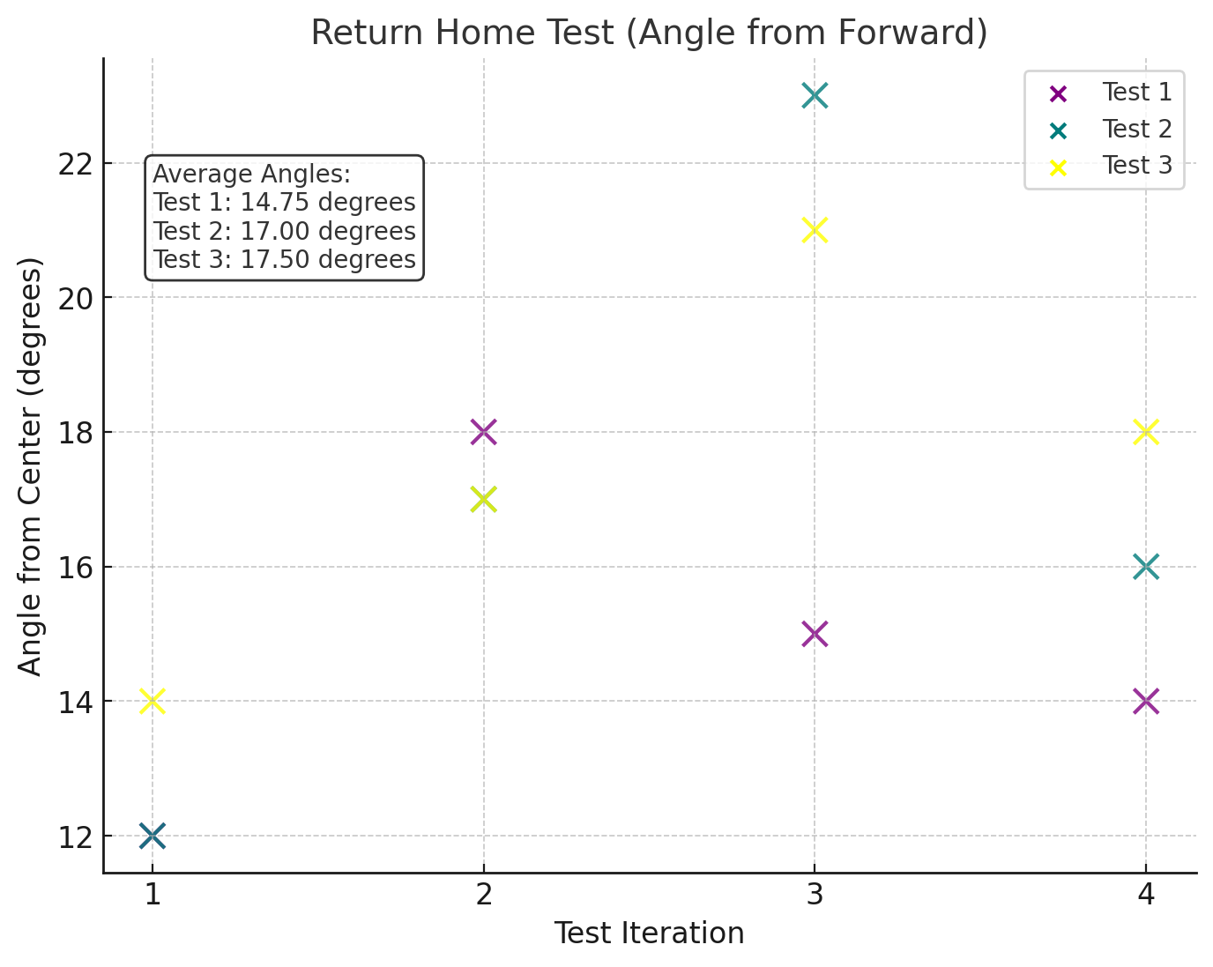

Figure 53: Return Home Test results (angle)

This test shows our capability to return to the position we deviated from. The displacement results show promising results however a big issue was the angle we were facing upon return. We averaged a return position of about 4 inches off the position we left from, however the angle we returned at was about 16.5 degrees off on average. This meant after returning to our position or bot would then struggle to move on to the next location it was commanded to go to.

#### Bump Sensor Collision

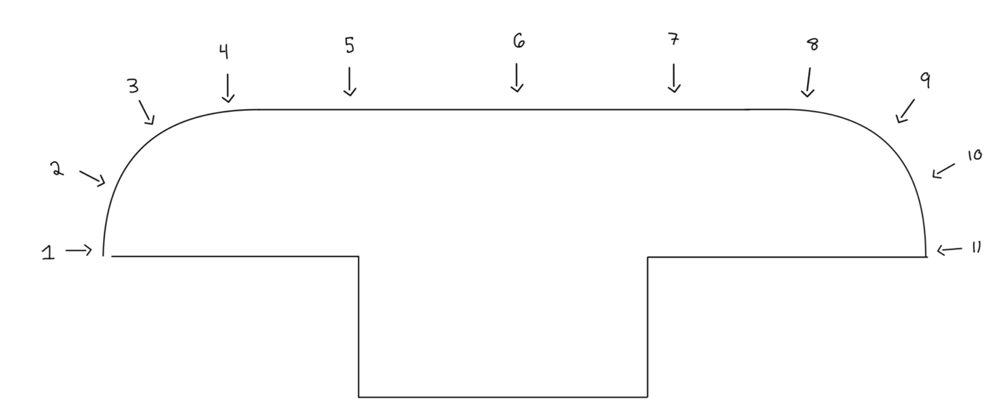

Figure 54: Bump Sensor Test Points

|  |  |  |  |
| --- | --- | --- | --- |
| Trial / Position | Outcome | Clicked? | Stopped? |
| 1 | Fail | No | No |
| 2 | Pass | Yes | Yes |
| 3 | Pass | Yes | Yes |
| 4 | Pass | Yes | Yes |
| 5 | Pass | Yes | Yes |
| 6 | Pass | Yes | Yes |
| 7 | Pass | Yes | Yes |
| 8 | Pass | Yes | Yes |
| 9 | Pass | Yes | Yes |
| 10 | Pass | Yes | Yes |
| 11 | Fail | No | No |

The bump sensor tests show that the front collision sensors work as intended. The bumper did fail to detect collisions where the bumper swings perpendicularly into an object, however this is a very unlikely scenario as the bumper is wider than the car. The car would have to be turning and almost wrapping an object for a collision of this kind to happen. To improve the bumper for passing all test cases, adding another limit switch on the very corner would detect this kind of collision.

#### Finite State Machine

##### Edge Cases

The first result is the Finite State Machine Edge Case with Simulated Peripherals from the ML algorithm and the rotary encoder. The green check marks indicate successful transitions while red ‘x’s indicate a failure.

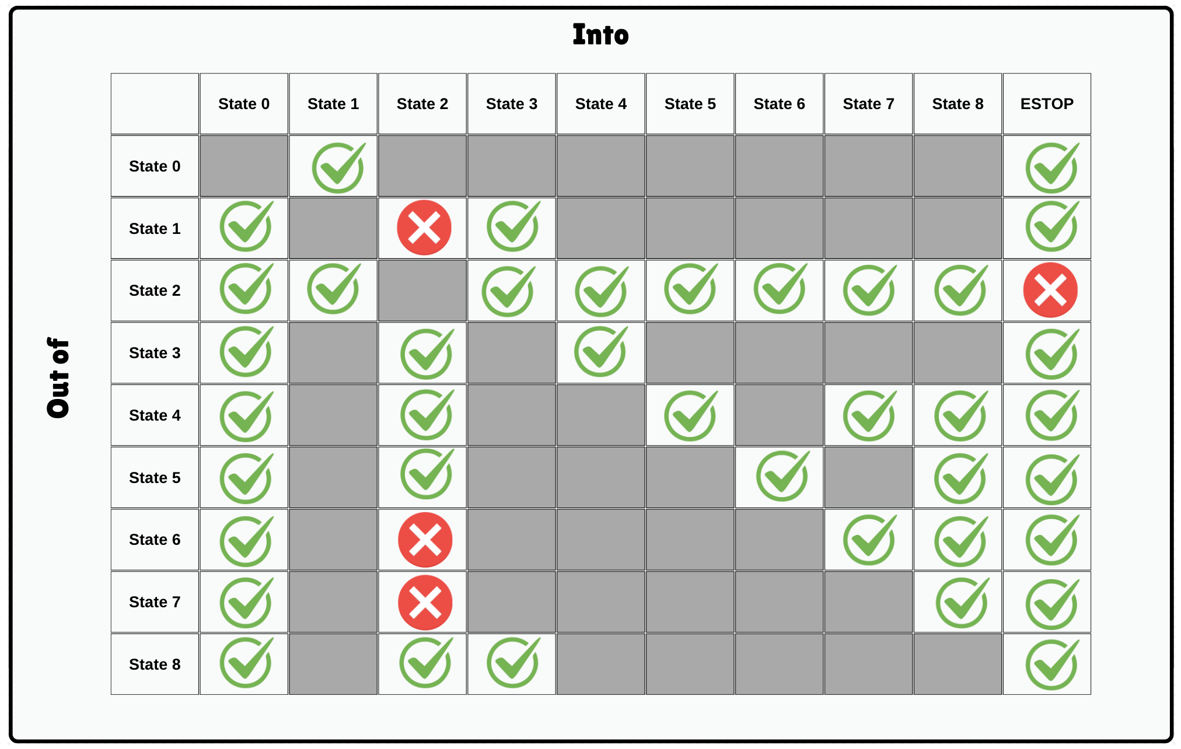

Figure 55: FSM Edge Case Table Simulated Peripherals

For the most part , the FSM was able to perform transitions as it should . However, we say a primary issue with the FSM getting stuck, and unable to do an interrupt transition (to states like 2 – Pause and ESTOP) when it was performing detections or was generating the path. These tasks are time consuming and present a safety concern. The design of our FSM just used a while loop that checked for new instructions at the top of the loop. So subprocesses lacked the ability to be interrupted.

The second test shows the result of running the results with the bot running on the ground with the path following program and detections running. As mentioned earlier, our ability to see where we were in the world was vastly incorrect. This means we were not able to test our full functionality of the FSM integrated with all parts. The orange circles indicate steps we were unable to test because of this.

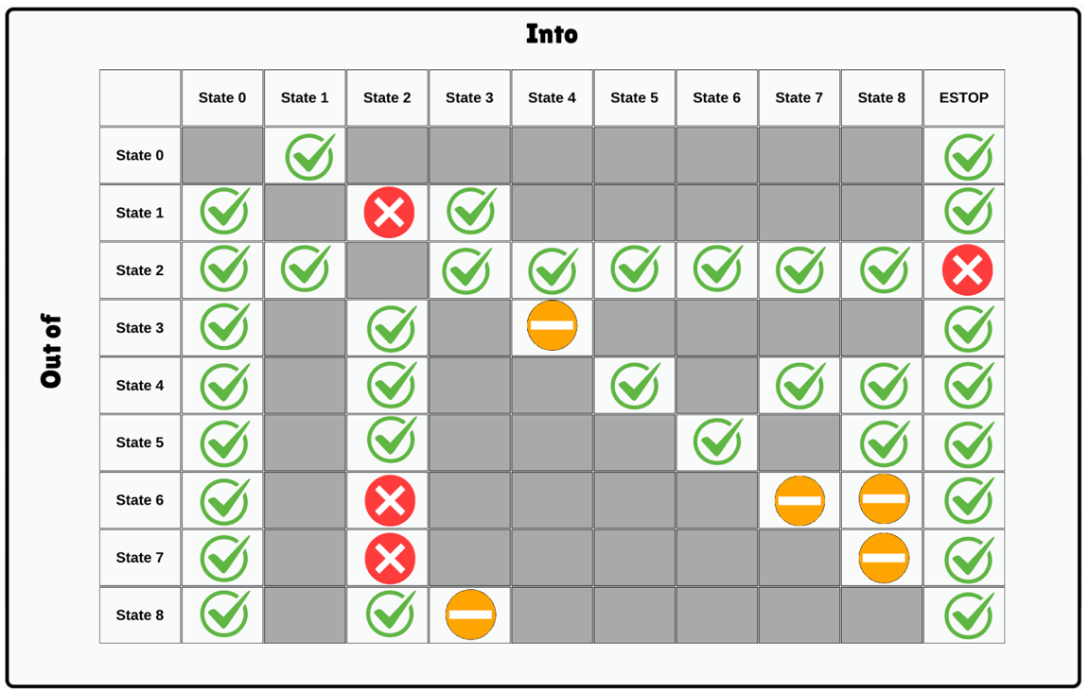

Figure 56: FSM Edge Case Table Non-Simulate Peripherals

When utilizing full peripherals, we got similar results to our first test (barring our limitations). With the machine learning models, whether we had detections, we were able to prove our FSM behaves as intended except for the cases we explained in test 1.

##### Latency

This test gathered overall 39 points of timing between different states of the FSM. In a random order

When gathering the data for this test, I noticed that there was one record of a very large delay. Out of 39 data points, one data point fell more than 3 standard deviations from the mean. In case this point was a fluke or tester error. I will analyze the data with and without it.

**Without Outlier…**

**Mean: 0.00418 seconds**

**Variance: 0.0001148 seconds²**

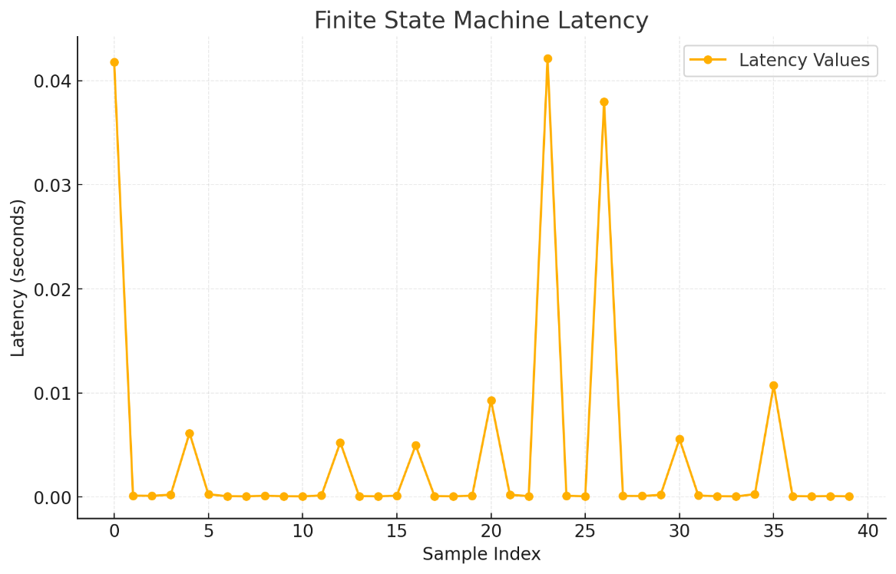

Figure 57: FSM Latency without Outlier

If you notice in this there are four distinct timing peaks {0.04s, 0.01s, 0.005s, and everything else close to 0.0s}. These peaks each are defined by different states and transition out of them.

The most time-consuming peaks (around 0.04 seconds). Refers to entering and exiting the 2 – The Pause State. I believe these peaks exists because Pausing forces us to pause and restart the machine learning models, which takes computation power.

The second highest peak is the transition from State 7 to State 8. I believe that is because the machine learning model that is being utilized in State 7. It takes up of more of the Jetsons computing abilities and may slow it down.

The third peak (0.005 s) is transitioning out of State 4 to State 5. I believe that is because the machine learning model that is being utilized in State 4. It takes up of more of the Jetsons computing abilities and may slow it down.

All other states fall in the around 0.0s category.

While there is a level of variation. for a real-time system, this timing falls within a reasonable range.

**With Outlier…**

**Mean: 0.06781 seconds**

**Variance: 0.1621 seconds²**

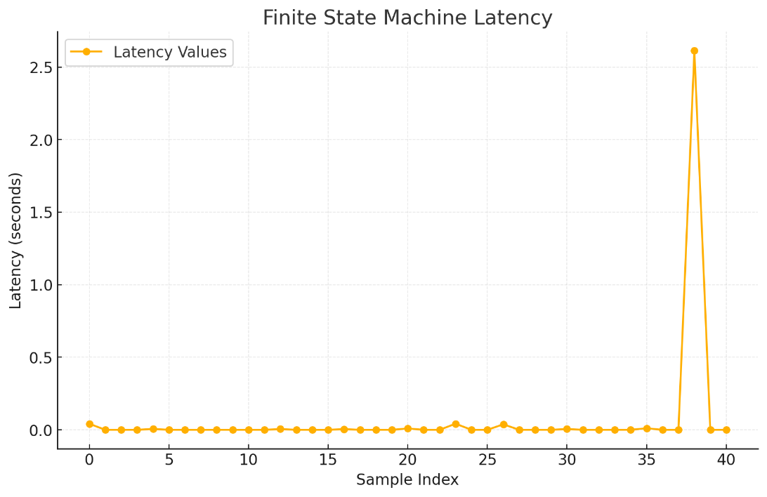

Figure 58: FSM Latency with Outlier

As we can see, this outlier is quite large to the rest of the data. This was associated with the Stopped State (0) that in all other instances fell in the about 0.0s category. While it is easy to assume that this is a test error, it could be highlighting a dangerous edge case that could cause the system to become non-Realtime. With more time, I would explore the issue and try to recreate it.

#### Bluetooth + Arduino Communication Latency

For this test 100 points of were collected on both the with a mean of 0.52 and a variance of 0.005. It is to be noted, that a message dropping rate of 5% was recorded but these messages were excluded from this test. Originally there was 105 messages sent from the UI.

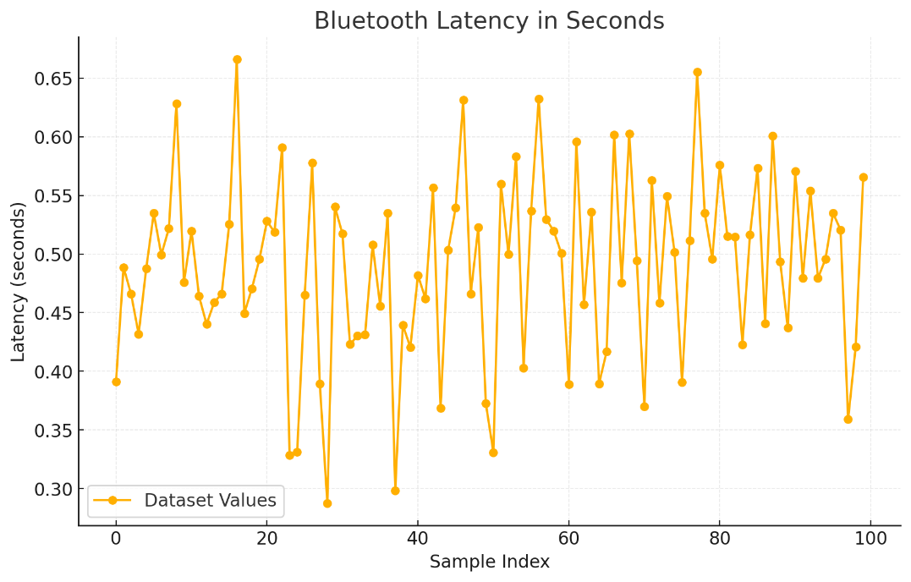

Figure 59: Bluetooth to Jetson Latency Graph

Our goal for this unit was to have a latency of 100ms or less. As you can see, we did not achieve this goal. The timing was relatively consisting of across types of messages but was around 400ms higher than we wanted. We believe that this was caused by the 1 core nature of the Arduino. Since the Arduino was also being periodically hardware interrupted for the rotary encode.

The dropout rate we discovered, which we were not originally testing for, is also of concern. For a real time system, loosing communication is a big concern because we are modeling ATC communication. To lose contact with ATC, leaves a big risk for the bot to become trash itself.

#### Path Planning Generation

As mentioned above, we choose qualitative results for the Path Planner to show how the paths would behave. In the first test, we ran in the same GPS points but if a different order. This was to highlight the ability of the program to always create a path that was on the outline of the runway, and would no intersect it.

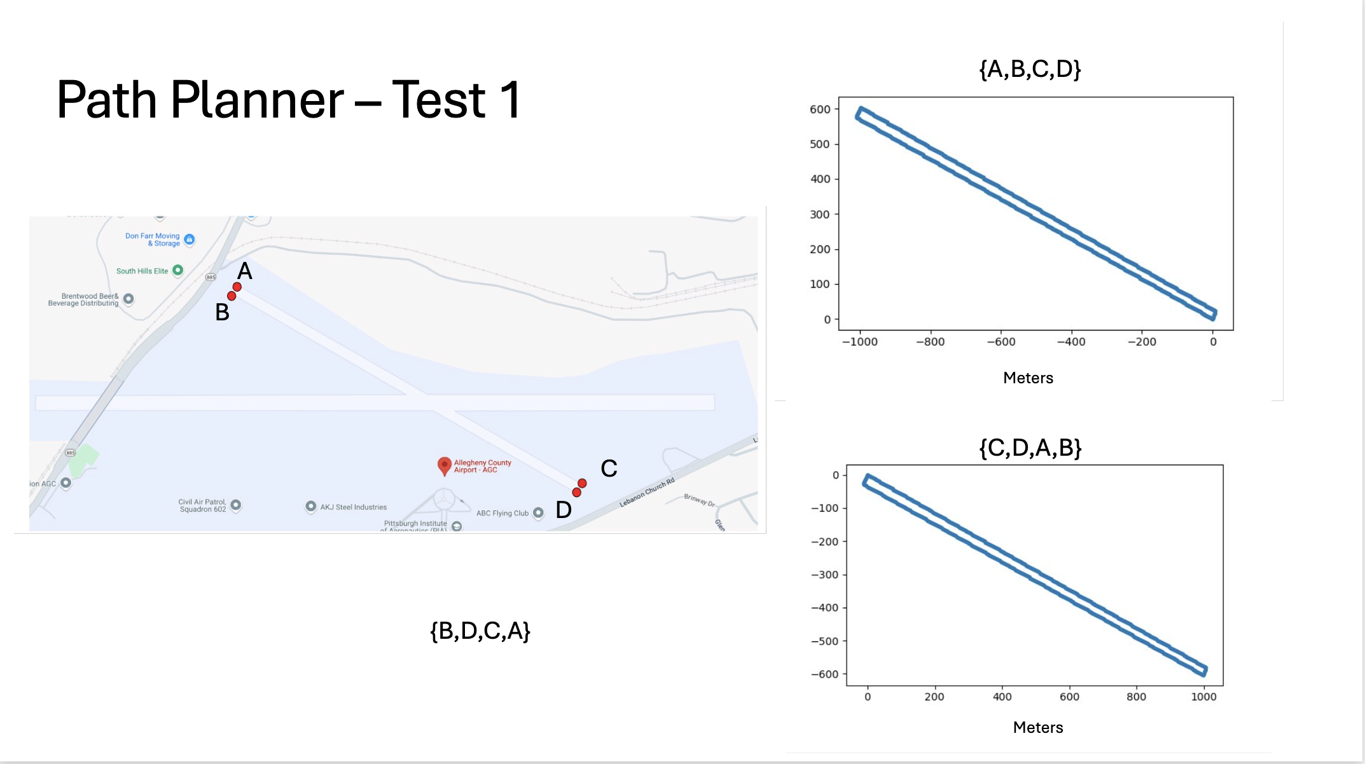

Figure 60: Path Planner Test 1

The second and third test show the tenacity of the program to do large and small scales and different directions.

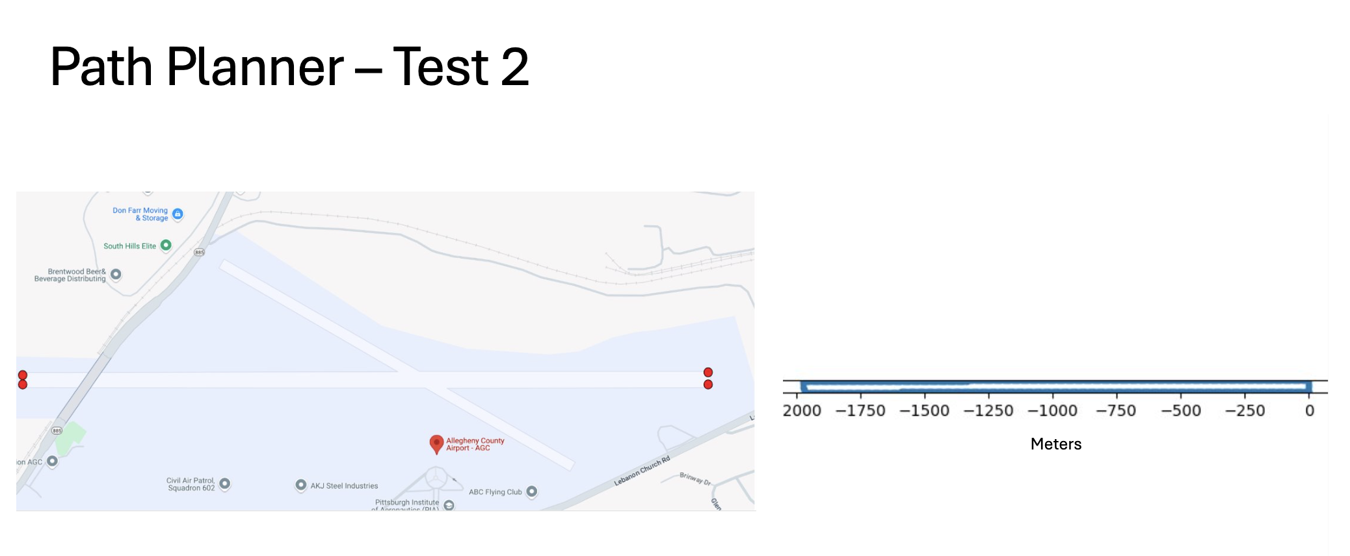

Figure 61: Path Planner Test 2

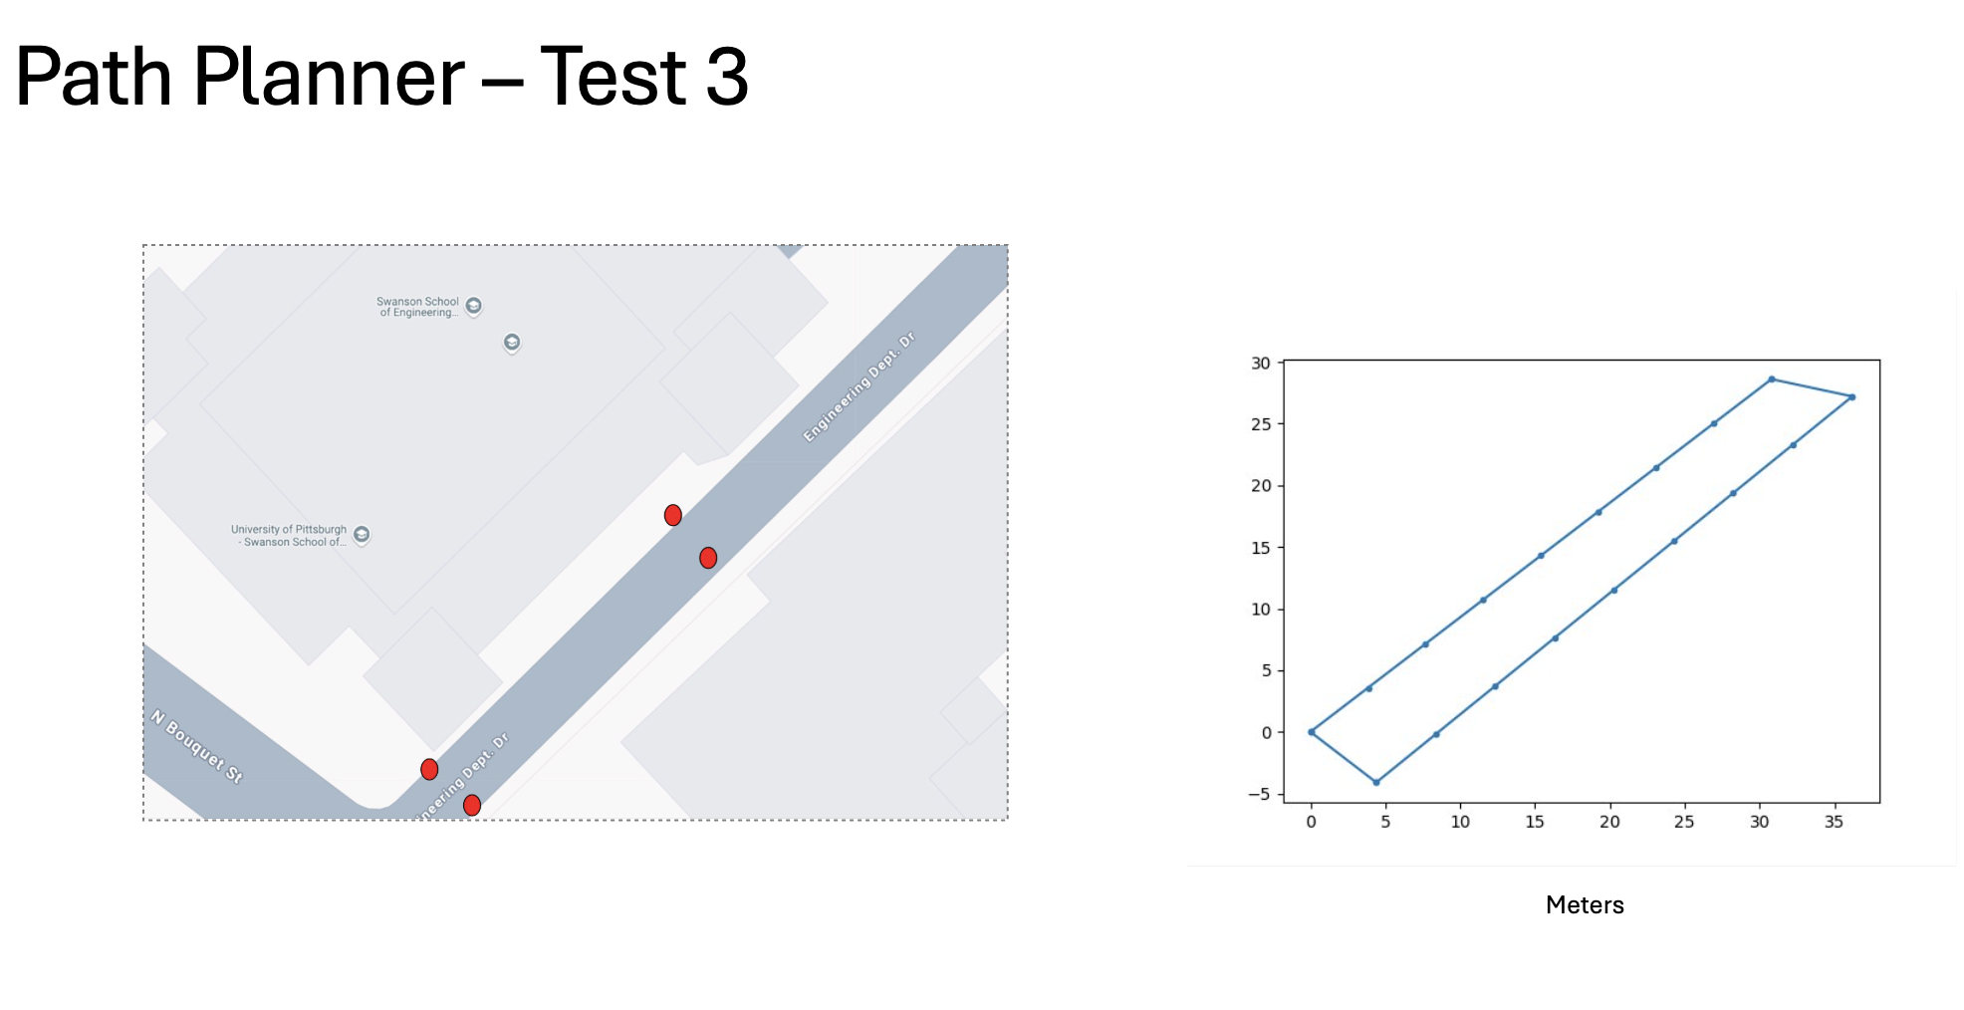

Figure 62: Path Planner Test 3

The fourth test highlights how the program handle any quadlateral shape, as long as it has four corners.

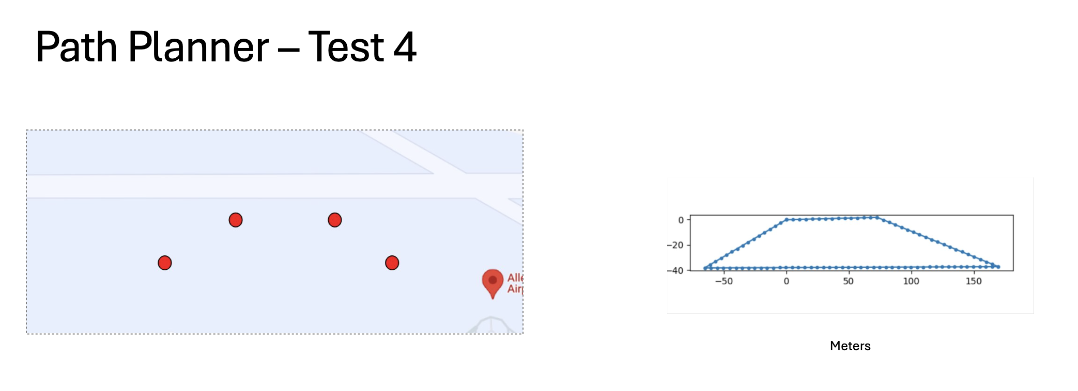

Figure 63: Path Planner Test 4

These last tests were to highlight the edge cases where paths should not be generated. For any shape with either less than 4 corners or a zero area, the path will not be generated. Nothing was outputted for these, so it proved this correct.

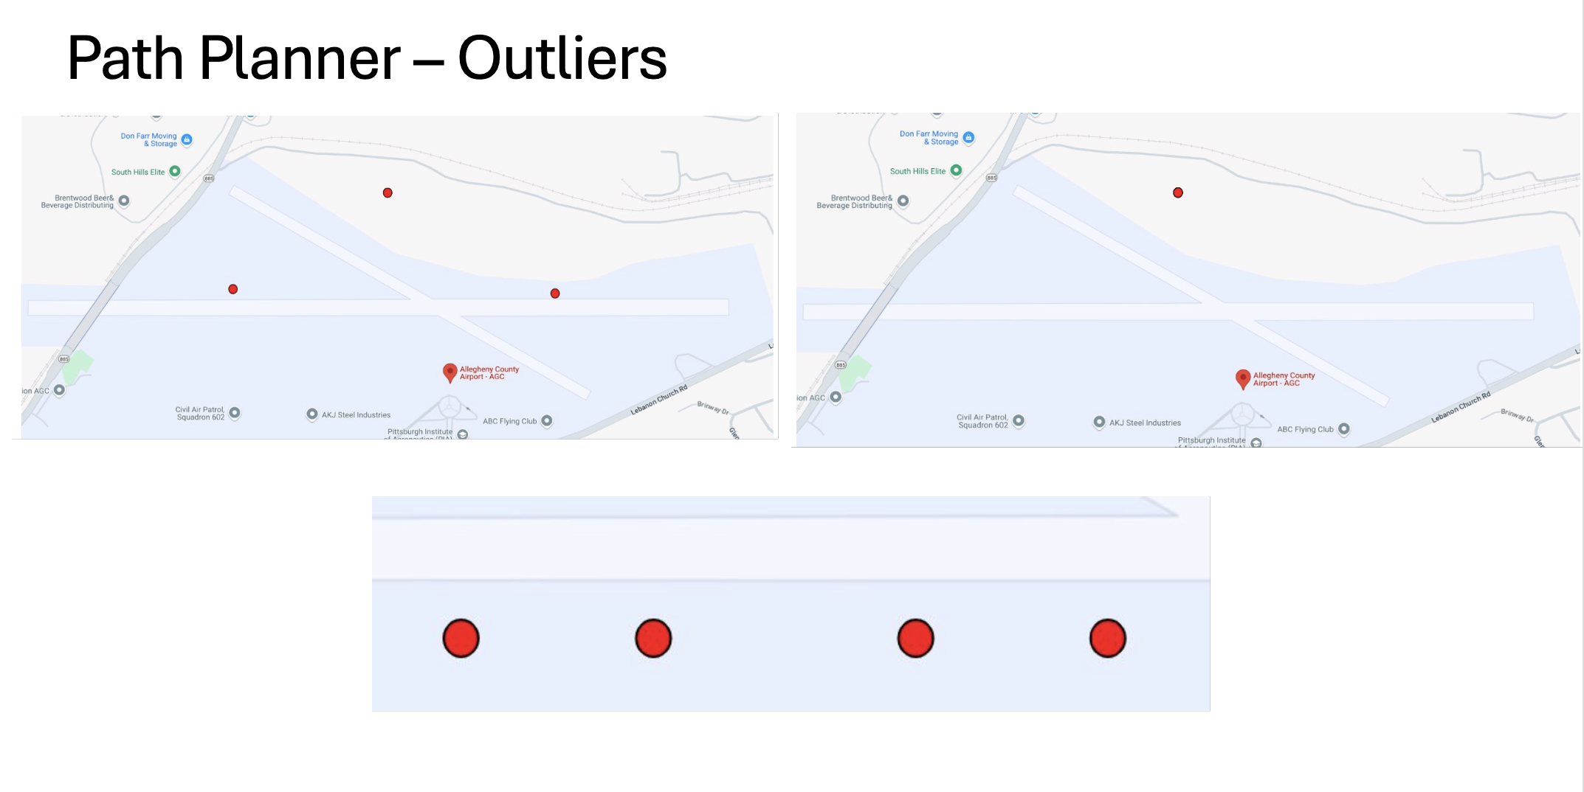

Figure 64: Path Planner Test – Outliers

#### UI Usability

1. Tim
   * + - 1. Accessibility - 10
         2. Easy to Understand - 7
         3. Covers Edge Cases - 8
       1. Miles
          1. Accessibility - 7
          2. Easy to Understand - 6
          3. Covers Edge Cases - 8
       2. Roldan
          1. Accessibility - 3
          2. Easy to Understand - 6
          3. Covers Edge Cases - 8
       3. Angie
          1. Accessibility - 10
          2. Easy to Understand - 8
          3. Covers Edge Cases - 10
       4. Travis
          1. Accessibility - 10
          2. Easy to Understand - 9
          3. Covers Edge Cases - 9
       5. Keshav
          1. Accessibility - 10
          2. Easy to Understand - 7
          3. Covers Edge Cases - 9
       6. Raheel
          1. Accessibility - 9
          2. Easy to Understand - 5
          3. Covers Edge Cases - 9
       7. J-Rod
          1. Accessibility - 8
          2. Easy to Understand - 6
          3. Covers Edge Cases - 7
       8. Brayden
          1. Accessibility - 8
          2. Easy to Understand - 6
          3. Covers Edge Cases - 8
       9. Lilly
          1. Accessibility - 9
          2. Easy to Understand - 6
          3. Covers Edge Cases - 7
       10. Tanvi
           1. Accessibility - 10
           2. Easy to Understand - 8
           3. Covers Edge Cases - 8
       11. Abby
           1. Accessibility - 6
           2. Easy to Understand - 7
           3. Covers Edge Cases - 7
       12. Alex
           1. Accessibility - 9
           2. Easy to Understand - 7
           3. Covers Edge Cases - 7
       13. Ahn
           1. Accessibility - 6
           2. Easy to Understand - 6
           3. Covers Edge Cases - 7
       14. Mathew Dudik (Mentor)
           1. Accessibility - 1
           2. Easy to Understand - 4
           3. Covers Edge Cases - 7

Accessibility Average– 7.43

Easy to Understand Average – 7

Covers Edge Cases Average – 8.2

Only one of our parameters met our goal of being greater than being 8. After listening to verbal feedback from these people, it’s clear that the edge cases were well thought out. However, the font on the UI was small, and overall, the buttons were not very straightforward. People especially struggled with inputting GPS coordinates into the UI.

# New Skills Acquired and Learning Strategies

## Lauren Gilfillan

### Python UI Generation

For the first time, I had to learn how to generate my own UI utilizing the python *Tkinter* library. As someone who has primarily worked in embedded, this was my first time designing and coding a UI from scratch. In addition to making it (semi) visually appealing, it had to cover many edge cases of users doing things incorrectly or in the wrong order. It gave me insight into how robust User Interfaces need to be.

### Bluetooth Communication Protocol on a laptop

To interface the UI with Bluetooth, I had to learn how to utilize asynchronous behavior on my laptop. Since Bluetooth is an interrupt-based protocol, I needed a way to be notified of messages. In addition, I needed to do research on different ways to interface Bluetooth with microcontroller. Luckily there are a lot of python Bluetooth libraries I got to try.

### Patience

One of the most harrowing parts of overseeing integration is having the patience to survive it. Because of how interdependent our modules were, integration was very stop and go. This required me to be patient with myself and others as we tried to figure out what link in the chain was failing. In addition, I think a huge piece of senior design is learning how to work effectively in a team. This class taught me about

## Chad Collina

### Interfacing with an ESC

Going into the project I had assumed that communicating with the ESC would be simple. I started by using the industry standard approach for controlling an ESC, but the car did not react how I had expected, and I could not control the motors. I then began looking for a datasheet for my specific controller but soon found out since it was an off the shelf RC car, datasheets for the components do not exist. The manufacturers did not expect any of the users to modify their cars and do not provide any resources to aid in doing so. Since I knew that the ESC uses PWM signals I started by just sending signals until I got the wheels to turn. After a lot more tuning, I had eventually concluded that my ESC in fact did follow the industry standard and the issue was how I was initializing the ESC. In the end I learned a lot about troubleshooting devices especially when there is a lack of documentation/support.

## Jonah Belback

### System Engineering and Architecture

There was a lot of time spent on how the python architecture was constructed. How modules were formatted, how they printed out in a way that was readable and useful, and how to best interact across them in a main. Specifically work with making the modules have detection of crashes and their management with raise errors and then offering alternative options. This takes a lot of time going through the flow of the modules and understanding all the libraries involved and developing a supportive architecture that allows going in and out of functions and objects. A lot of the techniques I used I had never thought of before but evolved and created during the development. In the end I feel exceedingly capable of making very dynamic architectural processes.

### ROS

Prior to this project I had never used ROS or created anything involving it, so learning it from scratch and developing my own subscribers to attach off Carnegie’s publishers with my own methods of spinning that detect an extended downtime of publishing was challenging. By the end I find myself to be able to read and understand other ROS architectures that I find online, and an even more capable System Engineering in software

### CNN Model

Working on a premade CNN architecture with its own overhead was a challenge figuring out how to best utilize and tweak its hyperparameters to specific design problems. Involving creating my own container for the model so I could convert its inputs and outputs to something more useful and specific, also researching input image sizes and tweaking hyperparameters then comparing results for the best possible results, and general a lot of online research on forums to discover more information about the architecture to find more things to adjust.

There was also a lot of work with the dataset and learning how to best collect large amount of different images for all the different classified objects in many different angles, orientations, and leaving in unwanted background objects. This is a learned skill and so is knowing when to cut your time to make better scripts to obtain images to maximize effectiveness.

I also learned about working off an exported PyTorch model converted to pure weights in the ONNX format and how to recreate some of the overhead to delete duplicate detections but in a way specific to my usability and drastically decrease runtime.

### Stereo Vision

The conversion problem from the Auxiliary Camera to the Left Mono-Chromatic Camera took a very long time to create a unique solution. There was no existing solution as I could find online and I used to approach I got from my classes, like using weights from my Intro to ML class, and from online research, the Epipolar line for researching Stereo Vision. It is a skill to take understanding from existing ideas to create an entirely different approach like the sliding window, which was a combination of both ideas in addition with something else I learned in class that was involved with something entirely different.

This experimentation, and the optimization of each individual approach, has cultivated my skill in decision-making, creativity, research, and Engineering. It also increased and tested my knowledge in many fields of computer vision but especially Stereo Imaging as to best break down the problem I had to self-research many parts of the field and understand them in depth.

## Justin Lipner

### Soldering

I already knew how to solder through hole components going into Senior Design, but during the semester I had to expand upon that skill. I learned how to solder surface mount components, which allowed me to solder the TPS54550 onto our PCB. I also learned how to solder cables together to create power cables, which was done to connect the Jetson and Arduino to the PCB.

Our jetson fell off the robot once during operation and the power jack was damaged. During the desolder process to replace the jack, the pads connected to it came off. Jim taught me how to work around this and I was able to restore the power jack functionality to our Jetson.

### Electronics

I’m used to using LTSpice for simulating circuit design, however, this wasn’t an option for the power supply I designed. I used an IC from Texas Instruments and the circuit model for it is not available to the public, so I had to learn how to use *PSpice for Ti* to simulate the IC. Additionally, I had to learn the most common approaches for implementing reverse current protections.

# Conclusions and Future Work

## Limitations

The main limitation of this prototype is no debris removal. There simply wasn’t enough time for us to implement such a feature. Comparing our prototype to the robot designed by the company AirTrek, a street sweeper-like add-on to remove debris is what we think is the ideal way to dispose of debris and something we would like to have on the robot.

The drivetrain of the bot provided prohibited our ability to accurately calculate and position ourselves on an XY plane. Knowing where we are and getting to where we want to go are vital to our bot's functionality. To be able to accurately perform both functions with the bot we had, tens to hundreds of hours of trial-and-error messing with multipliers would be needed or more simply a different drivetrain.

Weather and daylight. We were unable to complete the amount of testing we had hoped for, and timing was not on our side. We frequently tried to go outside and test our robot, but we were severely limited due to the daylight savings happening right as we were getting into testing. In the situations when we did have daylight, mother nature had decided it was a good time for rain or snow. Additionally, some of the times we did get outside to test it was around 30 degrees or below. This was great for the thermals of our computing devices however the batteries did not gain performance due to the temperature and they would die sooner giving us less time to test.

## What We’d Do Differently

### Chassis

We are very grateful for the chassis we were lent for this project however it turned out to be one large limiting factor in the project. The chassis is AWD with a locked center, front, and rear differentials. This meant the bot would understeer during every turn. The understeer was unable to be accounted for when using the bicycle model for calculating our position in an XY plane. There are multiple ways to combat this issue. A bot with chassis with open differentials, a 2-wheel drive bot that uses casters for support similarly to a Roomba, or an AWD bot with a motor per wheel that can be controlled independently are all valid solutions. This would greatly improve the ability to calculate its location on an XY plane.

### Microcontrollers

For our prototype we chose to use the Arduino to drive our motors and facilitate communication between the UI. As the Arduino is a single core microcontroller this means that there was a lot of context switching which lowered our performance. The encoder also would execute a hardware interrupt every 1/20th of a wheel rotation which meant using a PID controller was not possible. The variation in step counts while the PID controller was calculating the appropriate speed caused the bot to not drive up to specification and thus it was removed from the implementation.

Another change would be having the Bluetooth connection be directly connected to the Jetson. Since only one person could work with the Jetson at a time, we decided that the Bluetooth connection would be routed through the Arduino. We had multiple Arduinos on hand which meant the code for establishing connection could be worked on in parallel with the development of the Jetson programming. It was not worth setting development of the computer vision behind for our Bluetooth messages.

### Electrical

We would like to have all the electrical needs of the robot on one system. Using two different batteries for two different modules is clunky. More rigorous current and overvoltage protections would also be something implemented on a more advanced prototype to ensure reliability over long periods of time (span of months-years). There’s likely not an IC that could handle the power requirements for a combined system, so a custom buck regulator would have to be made. Finally, a surface mount version of the PCB would be preferred to reduce overall costs.

# References

## General

[G1] Federal Aviation Administration. 2022. “Concorde | Federal Aviation Administration.” Www.faa.gov. December 19, 2022. <https://www.faa.gov/lessons_learned/transport_airplane/accidents/F-BTSC>.

[G2] Hilburn, Brian G., and B S Pesmen. 2023. “Foreign Object Debris Detection System Cost-Benefit Analysis.” Edited by LLC Diakon Solutions. ROSA P. May 1, 2023. <https://rosap.ntl.bts.gov/view/dot/67541>.

[G3] “Wayback Machine.” n.d. Web.archive.org. [https://web.archive.org/web/20121224083810/http://insightsri.com/system/files/T he+Ecomonic+Cost+of+FOD+-+Jul08.pdf.](https://web.archive.org/web/20121224083810/http://insightsri.com/system/files/The+Ecomonic+Cost+of+FOD+-+Jul08.pdf)

[G4] “Research.” n.d. Department of Environmental Protection. <https://www.dep.pa.gov/Business/Land/Waste/littering/Pages/Research.aspx>.

[G5] Lee, Yongjin, Jaelim Cho, Jungwoo Sohn, and Changsoo Kim. 2023. “Health Effects of Microplastic Exposures: Current Issues and Perspectives in South Korea.” Yonsei Medical Journal 64 (5). <https://doi.org/10.3349/ymj.2023.0048>.

[G6] Borenstein, Seth. 2024. “Scientists Find about a Quarter Million Invisible Microplastic Particles in a Liter of Bottled Water.” PBS NewsHour. January 8, 2024. <https://www.pbs.org/newshour/science/scientists-find-about-a-quarter-million-invisible-microplastic-particles-in-a-liter-of-bottled-water>.

[G7] Bradley, Garnell. 2024. “The Impact of Microplastics Can’t Be Studied Because There Is No Control Group.” MedShadow Foundation | Independent Health & Wellness Journalism. February 8, 2024. <https://medshadow.org/the-impact-of-microplastics-cant-be-studied-because-there-is-no-control-group/>.

[G8] Koelmans, Albert A., Nur Hazimah Mohamed Nor, Enya Hermsen, Merel Kooi, Svenja M. Mintenig, and Jennifer De France. 2019. “Microplastics in Freshwaters and Drinking Water: Critical Review and Assessment of Data Quality.” Water Research 155 (1): 410–22. <https://doi.org/10.1016/j.watres.2019.02.054>.

[G9] Darrah, Petrina. 2023. “How Many Marine Animals Die from Plastic Pollution? | GVI.” Www.gviusa.com. May 16, 2023. <https://www.gviusa.com/blog/smb-how-many-marine-animals-die-from-plastic-pollution/>.

[G10] Cooper, Rachel. 2019. “Plastic Pollution Affecting Wildlife at an All-Time High, Finds RSPCA - Climate Action.” Www.climateaction.org. February 4, 2019. [https://www.climateaction.org/news/plastic-pollution-affecting-wildlife-at-an-all-t ime-high-finds-rspca](https://www.climateaction.org/news/plastic-pollution-affecting-wildlife-at-an-all-t%20ime-high-finds-rspca).

## Electrical

[E1] Datasheet for buck regulator IC - <https://www.ti.com/lit/ds/symlink/tps54550.pdf?HQS=dis-dk-null-digikeymode-dsf-pf-null-wwe&ts=1734048234195&ref_url=https%253A%252F%252Fwww.ti.com%252Fgeneral%252Fdocs%252Fsuppproductinfo.tsp%253FdistId%253D10%2526gotoUrl%253Dhttps%253A%252F%252Fwww.ti.com%252Flit%252Fgpn%252Ftps54550>

[E2] Reverse current protections - <https://www.youtube.com/watch?v=IrB-FPcv1Dc>

[E3] Stereo Camera Specs - <https://www.carnegierobotics.com/AutonomousVehicles/CameraManufacturing/StereoCameraManufacturing/KS21i/Files/KS21i_Data_Sheet_CRL.pdf>

[E4] Jetson Orin Specs - <https://developer.download.nvidia.com/assets/embedded/secure/jetson/orin_nano/docs/Jetson-Orin-Nano-DevKit-Carrier-Board-Specification_SP-11324-001_v1.2.pdf?XUKnVqkyFLivF_YLj3wVaOSgKWaJ6QZj92dgLEvbClZvC3NJzG2o4BHneIqDis8MLUuvKZ-gUM_NWJGoUeaIcfeNf-i7sBwONkH93Wf_r1m_1JQvgcz3q5hFNs3C6B1I0C6Jp467RJFJS7wc3CLobn828HyZ_Bxrx7cy0xq-bw61f0iHWufo1nQtKCfWJ7ewOztJHVN3qLJco0ga8JCme7gXnJRXEAw7AWrnFeeKg-WX0Jst_g==&t=eyJscyI6ImdzZW8iLCJsc2QiOiJodHRwczovL3d3dy5nb29nbGUuY29tLyJ9>

## Software

[S1] Open Robotics. 2020. “ROS.org | Powering the World’s Robots.” Ros.org. 2020. <https://www.ros.org/>.

[S2] Docker. 2024. “Enterprise Application Container Platform | Docker.” Docker. 2024. [https://www.docker.com/.](https://www.docker.com/)

[S3] Jocher, Glenn. 2020. “YOLOv8 Documentation.” Docs.ultralytics.com. May 18, 2020. <https://docs.ultralytics.com/>.

[S4] “Sign in to Roboflow.” n.d. App.roboflow.com. <https://app.roboflow.com/>.

[S5] “Turtneck - Overview.” 2024. GitHub. 2024. <https://github.com/turtneck>.

[S6] Instructables. 2015. “How to Create an Android App with Android Studio.” Instructables. Instructables. March 26, 2015. <https://www.instructables.com/How-To-Create-An-Android-App-With-Android-Studio/>.

[S7] Instructables. 2015. “Build Android Bluetooth App for Arduino.” Instructables. Instructables. September 6, 2015. <https://www.instructables.com/Build-Android-Bluetooth-App-for-Arduino/>.